December 2025 BOARD UPDATE

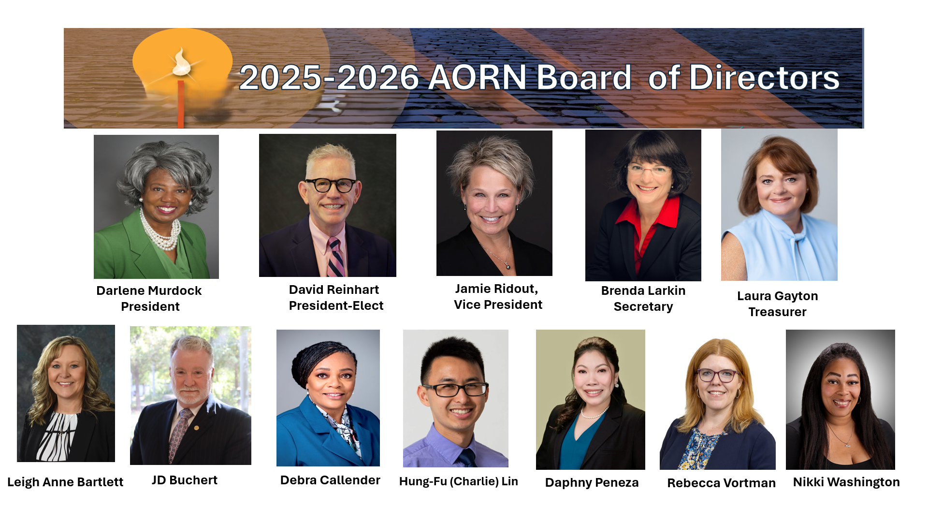

Welcome to 2026! Another year has flown by, and the board is continuing to move forward to the culmination of our work at the AORN Global Surgical Conference & Expo. We are all looking forward to being with you in New Orleans and renewing our hearts, minds and spirits as we continue to work on our Mission and Vision of providing indispensable evidence-based resources to establish the standards of excellence for each phase of perioperative nursing care to achieve optimal outcomes for every patient, every time.

AORN does not operate in a vacuum but must adapt to all changes in the environment which impact perioperative nursing. Some of the events and innovations expected in the United States for 2026 include:
- Sports fans will enjoy the FIFA World Cup hosted across North America, Super Bowl LX in California, and the Winter Olympics in Italy featuring top U.S. athletes.
- Politically, midterm elections will reshape the congressional landscape. Policy and regulatory shifts will include:
  - Expiration of enhanced ACA Subsidies expected to increase premiums and uninsured rates.
  - Medicare drug negotiation and site-neutral payments by CMS take effect.
  - Healthcare policy shifts, AI regulations, and energy-efficiency standards will influence everyday life.
- Technology surges ahead with agentic AI, solid-state batteries, and 6G trials transforming industries. Will transform healthcare even more in multiple areas, most of which will impact how we care for patients undergoing operative and other invasive surgeries. Here are a few examples of what you can expect:
  - Medical Imaging & Diagnostics
    - AI algorithms analyze X-rays, MRIs, and CT scans to detect conditions like cancer, fractures, or neurological disorders with high accuracy—often spotting subtle patterns that humans might miss.
  - Predictive Analytics for Patient Care
    - Hospitals use AI to predict patient deterioration, readmission risks, and sepsis onset by analyzing vital signs and historical data in real time.
  - Drug Discovery & Development
    - AI accelerates drug research by modeling molecular interactions and predicting which compounds are most likely to succeed, cutting years off traditional timelines.
  - Virtual Health Assistants
    - AI-powered chatbots and voice assistants help patients schedule appointments, answer medication questions, and provide symptom triage, improving access to care.
  - Personalized Treatment Plans
    - Machine learning models tailor therapies based on genetic data, lifestyle, and medical history, especially in oncology and chronic disease management.
  - Remote Monitoring & Wearables
    - AI interprets data from smartwatches and medical devices to track heart rate, glucose levels, and sleep patterns, alerting clinicians to anomalies instantly.
- NASA’s Artemis II mission will send astronauts on a lunar flyby—the first since 1972—alongside multiple private lunar landings and Mars-bound projects.
- All these developments lead to a defining moment: the United States’ 250th anniversary of independence, a quarter-millennial celebration marked by nationwide festivities honoring the nation’s enduring legacy.

Looking forward to embracing the future with you all,
Brenda Larkin
Brenda G. Larkin, MS, APRN. ACNS-BC, CNS-CP, CSSM, LSSGB, CNOR, FAORN, AORN Secretary

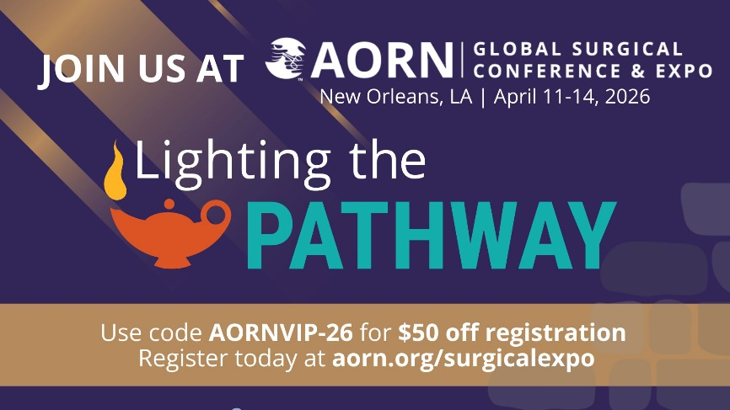

Save the date for AORN Global Conference & Expo in New Orleans, LA, April 11-14, 2026

Click here for registrations details

Chapter Officer Town Hall:
If you missed the November Chapter Officer Town Hall Recording, it can be accessed here.

The Next Chapter Officer Town Hall will be held Thursday, January 22nd at 5:00 MT – 6:00 MT. Chapter officers can register here: Click here

National Legislative Forum:
Missed the December NLF call? Catch up with the latest legislative news with the recording Click here.
There will be no call in January. However, you can review all the AORN Government Affairs Report for 2025 Click here.

Guidelines Public Commenting Opportunities:

The next Guideline for Integration of Artificial Intelligence is available from December 23, 2025 through January 31st.
This new guideline provides evidence-informed practical guidance for perioperative team members on
structuring a comprehensive governance framework for the oversight of artificial intelligence (AI); effectively participating in the integration of AI; engaging in lifecycle management of AI-enabled technologies throughout their use in the perioperative practice setting; recognizing and addressing implications that are common in health care AI, including ethical, legal, reliability, and trustworthiness concerns; participating in research that includes AI;
understanding examples of AI use in clinical practice that were identified in the literature; and participating in education, policy and procedure management, and quality assurance for AI in the perioperative practice setting.
Click here to comment.

Membership Update:

AORN supports members at every career stage and progression. Check out the Career Hub where you can explore your options in and around the OR. Click here to explore Career Pathway resources.

If achieving your CNOR is on your checklist for this year, click here to learn more about AORN CNOR Exam Prep help.

AORN also offers career coaching, resume advice and many other professional resources including Job opportunities and our exclusive Salary Calculator. Click here to explore our Career Center.

UPCOMING EVENTS:

Upcoming Live Webinars/Virtual Events:
Perioperative Nurses Leading Research
Whether you're already a devoted researcher, or curious about how you might make your mark on perioperative practice through a research project, join your colleagues at AORN's annual Perioperative Nursing Research Symposium taking place live online over two, 4-hour sessions, from 10:00am-2:00pm MT, January 21 & 22, 2026.
Participants will:
- Learn how to fill gaps in evidence and advance perioperative practice.
- Interact with colleagues who will present their research.
- Discover the steps to disseminate evidence-based practice or research project findings.
- Get ideas and mentoring from leading periop nurse researchers.
Register Now
- Receive up to 8 ANCC CH

Center for Perioperative Leadership
Whether you are aspiring to become a manager, recently moved into a new leadership position, or are an experienced nurse executive, AORN’s Center for Perioperative Leadership is focused on supporting your professional development throughout your career.
There are courses, webinars and a monthly Leader Exchange where you can develop your perioperative leadership expertise and a Periop Leader Blog which is your go-to resource for expert ideas, practical strategies, and the latest trends in perioperative care. This is an essential must-have for every perioperative leader! Click here to discover resources you can put to use right away!

Board Representation Activities:
President Murdock:
Jan 10: AORN of New Orleans Chapter 1902 Annual Winter Seminar & Vendor Fair
Jan 16 & 17: TCORN Annual Symposium & Vendor Fair
David Reinhart:
Jan 10: AORN of New Orleans Chapter 1902 Annual Winter Seminar & Vendor Fair
Jan 17: TCORN Annual Symposium & Vendor Fair
Brenda Larkin:
Jan 10: AORN of New Orleans Chapter 1902 Annual Winter Seminar & Vendor Fair
Jan 13: AORN Tri-County Chapter 3907
Jan 13: AORN of Greater Houston Virtual
Jan 16 & 17: TCORN Annual Symposium & Vendor Fair
Jan 19: Leadership Specialty Assembly
Jan 27: eChapter
Leigh Anne Bartlett:
Jan 16 & 17: TCORN Annual Symposium & Vendor Fair
JD Buchert:
Jan 6: TCORN Leadership Meeting
Jan 10: New Orleans Chapter Winter Symposium, New Orleans, LA
Jan 13: eChapter Education Committee Meeting
Jan 16& 17: Texas Collaboration of Perioperative Registered Nurses (TCORN) Symposium- Dallas, TX
Jan 19: AORN Leadership Specialty Assembly (?)
Jan20: Dallas AORN Chapter Meeting
Laura Gayton:
Jan 10: New Orleans Chapter Winter Symposium, New Orleans, LA
Jan 16 & 17: TCORN Annual Symposium & Vendor Fair
Charlie Lin:
Jan 10: AORN of North Texas
Jan 10: AORN of Silicon Valley
Daphny Peneza:
Jan 15: AORN Greater Kansas City
Jan 17: Texas Collaboration of Perioperative Registered Nurses (TCORN) Symposium- Dallas, TX
Rebecca Vortman:
Jan 10: AORN of New Orleans Chapter 1902 Annual Winter Seminar & Vendor Fair
Jan 13: AORN St. Louis Chapter Meeting
Jan 17: TCORN Annual Symposium & Vendor Fair
Nikki Washington:
Jan13: AORN of Greater Houston
Jan 17: TCORN Annual Symposium & Vendor Fair
Jan 20: Cal/OSHA Advisory Committee Meeting on Occupational Exposure to Plume in Healthcare
Jan 25: The Global Operating Room Meeting

Quote for the Month:

New Year's Day. A fresh start. A new chapter in life waiting to be written. New questions to be asked, embraced, and loved. Answers to be discovered and then lived in this transformative year of delight and self-discovery. Today carve out a quiet interlude for yourself in which to dream, pen in hand. Only dreams give birth to change.

Sarah Ban Breathnach

AORN’s Mission, Vision, & Values
Mission: AORN defines, supports, and advocates for patient and staff safety through exemplary practice in all phases of perioperative nursing care using evidence-based guidelines, continuing education and clinical practice resources.
Vision: AORN will provide indispensable evidence-based resources to establish the standards of excellence for each phase of perioperative nursing care to achieve optimal outcomes for every patient, every time.
Values:
- Innovation: Taking courageous and bold actions for growth and sustainability.
- Communication: Exemplifying respect, collaboration, transparency and honesty.
- Quality: Ensuring accountability and excellence.
- Diversity, Equity & Inclusiveness: Promoting fairness, valuing differences, considering all perspectives.
- Achievement: Achieving our mission, realizing the vision.

