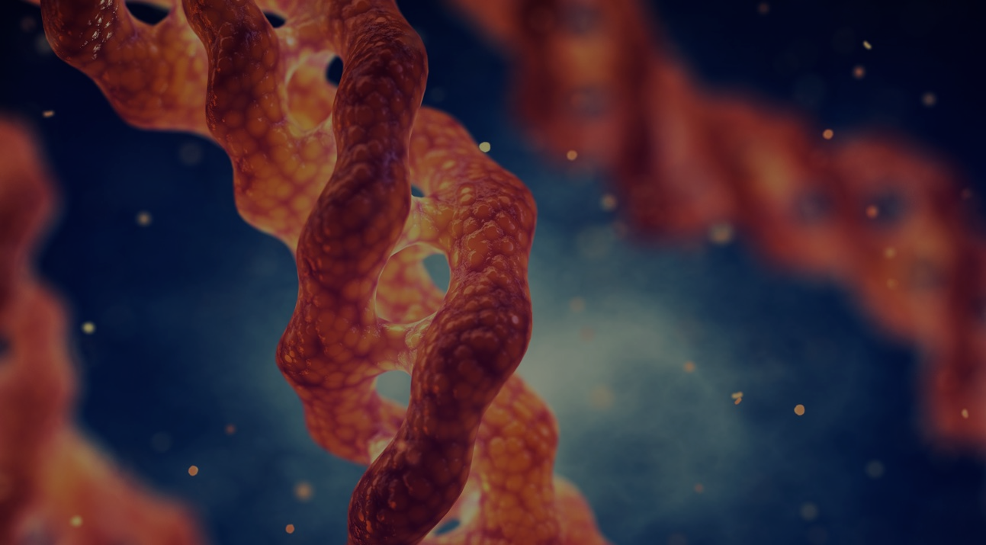  - 2/23/2026  The Science of Collagen  CE PROGRAM  This 1.0-hour continuing education course offers an in-depth exploration of collagen’s critical role in wound healing. Participants will examine collagen structure and function, as well as key factors influencing collagen synthesis. The course discusses various collagen products, highlighting their similarities, differences, and roles in supporting both acute and chronic wound management. The program also reviews clinical applications, contraindications, and emerging collagen-based technologies designed to optimize tissue repair and healing outcomes.  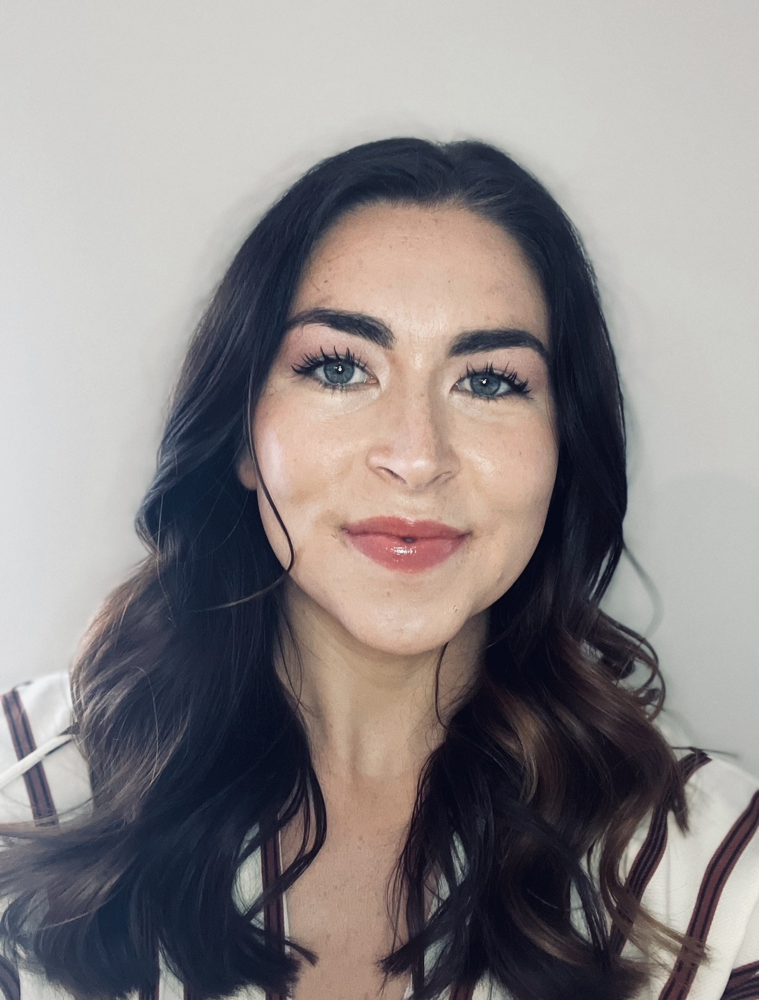  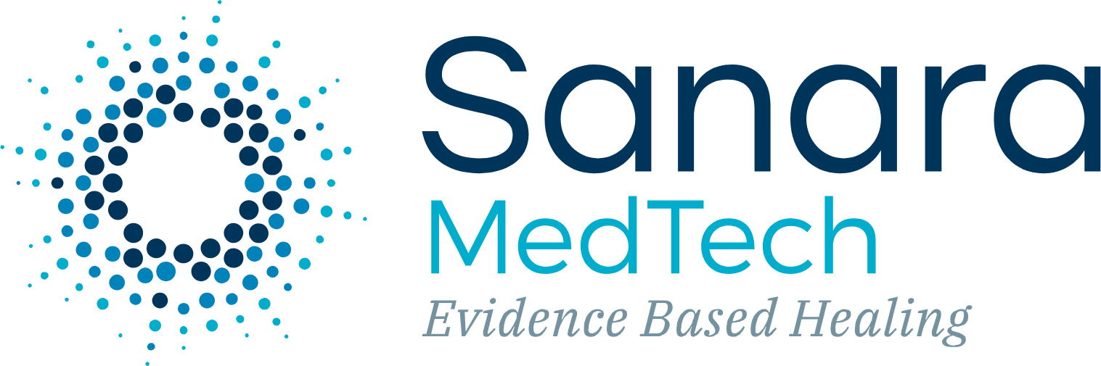  Presenter:  Mary Stanton BSN, RN
  The Science of Collagen
  ____
  Audience: Central Valley AORN Chapter
  ____
  Time: 5:30 pm February 23rd, 2026
  ____
  Location: The Point Patio Bar
  2940 E. Nees Ave., Fresno, CA 93720
  ____
  Provider approved by the California Board of Registered Nursing, Provider Number 17423 for 1.0 contact hour.
  Limited Seating!!!!
  25 attendees only!
  Must RSVP
  Kscaffidi@valleychildrens.org
  Kris Scaffidi

