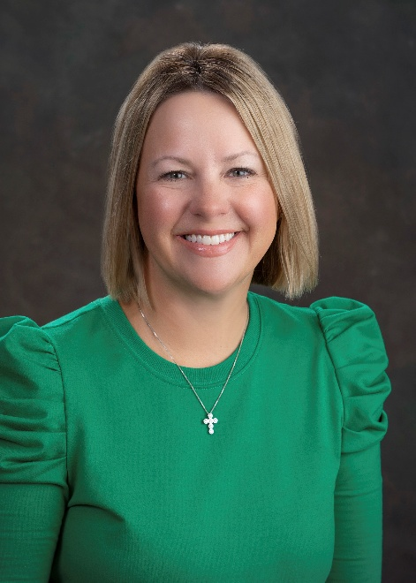

KONL is pleased to spotlight Board Member Ashley Denton. She serves as District Director Twin Lakes Region and has been a strong leader within the KONL Program Planning Committee, participating in statewide efforts to address healthcare and promote the profession of nursing. She a member of both KONL and AONL and is a published author, co-authoring “Pediatric Sepsis: Are You Ready?” in American Nurse (2022).
A recognized leader, Ms. Denton actively contributes to nursing councils, quality improvement committees, and community initiatives. She serves as Director of Accreditation and Patient Safety at Owensboro Health, Inc., where she leads system-wide initiatives to promote a culture of high reliability and continuous improvement. With nearly 25 years of nursing experience, Ashley has a proven track record in clinical care, nursing education, and healthcare operations. Ms. Denton holds certification as a Healthcare Accreditation Certified Professional. She is a 2025 recipient of the Owensboro Health President’s Award, recognizing her for demonstrating the core commitments of the organization.

