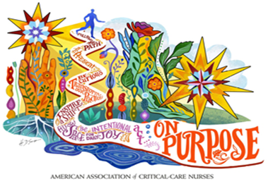
DIAMOND STATE CHAPTER BUSINESS MEETING - 01/13/2026 @6pm
Bayhealth Hospital Kent Campus – PCU Conference Room
Zoom Link:
https://us06web.zoom.us/j/84722414855?pwd=EIYMbbp3RRtCrJbPTWmILmDQhrOmlc.1
Meeting ID: 847 2241 4855 Passcode: DSC
One tap mobile
+13052241968,,84722414855#,,,,*158086# US
+13092053325,,84722414855#,,,,*158086# US
AGENDA
- Review of October minutes deferred to next meeting.
- Announcements/Celebrations
- Bylaws-emailed and electronic voting
- Standing items
  - Treasurer Update-Megan
  - National Board updates-Danette
  - Journal Club Volunteers-February & April
- Upcoming Events
  - See Below
- Celebrations
  - Certified Nurses Day March 2026
  - Birthdays
  - Welcoming new members-pins/card
- 2026 Symposium Planning September 24 and 25, 2026
  - Update
- 2026 NTI
  - Early Bird Registration Feb 2nd
  - Scholarships
- Student Nurse Meet and Greets
  - Del Tech
  - DSU
  - UD
- Community Outreach
  - Food Bank of Delaware
- Member Check-in
July  Board transition mtg | August  - Meet and greet/business mtg-Bayhealth in Dover and virtual | September  - Networking Happy Hour Firebirds  - Circle of Excellence awards nominations due
October  - Chapter Anniversary Celebration  - Business meeting at Bayhealth Sussex and virtual  - Journal Club | November  - Chapter excellence nominations due  - Education Dinner | December  - Fireside virtual chat with National President  - Meet and greet/business mtg-Christiana in Newark and virtual  - Holiday celebration
January  Education Dinner  Newark | February  - Meet and greet /business mtg-Bayhealth at Sussex and virtual  - Scholarship applications due  - Journal club | March  - Certification celebration  - Education dinner-Middletown
April  - Business Meeting-Christiana at Smyrna or Wilmington and virtual  - Journal club | May-no mtg  NTI/LDW | June  - Vote for new board  - End of year meet and greet at a restaurant

