Subject: Protect Your Patients. Protect Your License. Join Us April 29th.

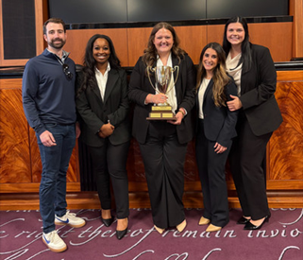
ASNA District 1 invites you to a powerful and engaging Mock Trial event on April 29, 2026, at Stovehouse in Huntsville. This live, realistic courtroom reenactment is designed to equip today’s nurses with the knowledge and confidence to protect their patients, their practice, and their professional license.
We are honored to welcome the award-winning Cumberland School of Law Mock Trial Team, known for their nationally recognized realism and dynamic courtroom performance. Their presentation will take you inside the legal system as they walk through every phase of a medical malpractice trial—from opening statements to verdict.
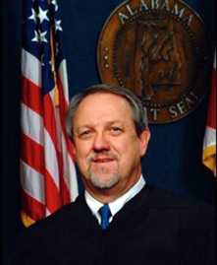
We are also very pleased to feature Judge Dennis O’Dell, retired Madison County Circuit Court Judge and current mediator with Siniard Law. Judge O’Dell brings decades of judicial experience and will provide valuable insights into how nursing documentation, communication, and clinical decision-making are evaluated in the courtroom.

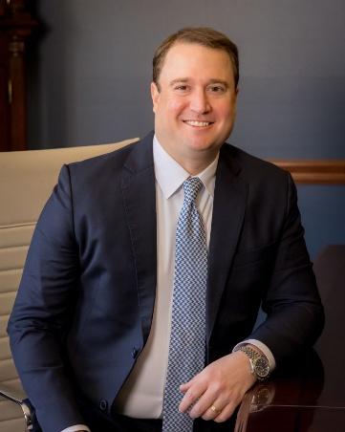
Additionally, you will hear from Barnes Heyward, attorney with Siniard Law, whose work focuses on representing injury victims throughout North Alabama. A graduate of Cumberland School of Law, Barnes began his career under the mentorship of the Honorable S.A. Watson, Jr., developing a reputation for meticulous trial preparation and client advocacy. He has been recognized as a National Trial Lawyers Top 40 Under 40 honoree in personal injury and a SuperLawyers Rising Star. Barnes has helped recover more than $12 million for injury victims across the region.
During this immersive event, you will learn from and interact with our presenters, deliberate alongside your colleagues, and ultimately cast your vote to decide the final verdict. This engaging approach ensures that every participant leaves with a deeper understanding of how courtroom decisions are made—and how nursing actions play a critical role.
You will also learn:
• How attorneys build and challenge malpractice cases
• The ways documentation can defend—or undermine—your professional standing
• What to expect if you are called as a witness
• Practical steps to protect your patients and your license
Event: ASNA District 1 Mock Trial
Date: April 29, 2026
Location: Stovehouse, Huntsville, Alabama
Reserve your spot today and help us plan for a strong turnout.
We look forward to seeing you at this important and impactful event.
Sincerely,
Alabama State Nurses Association – District 1

