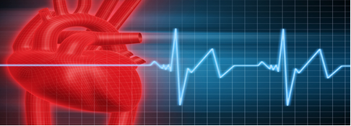

Please note venue change:

Seacoast Critical Care Group presents:

When Charts Become Evidence:
Nursing Documentation, Litigation Pitfalls, & the Risk of Becoming an Accidental Expert in NH
Presenter: Steven Gahan, Esq

When: Wednesday, January 28, 2026
Where: Charles Thayer Building, Portsmouth, NH (behind the Jackson Gray Medical Bldg on Borthwick Ave)
Contact Hours : 1.5

5:30 – 6:00p Chapter Welcome & Meeting - (pizza provided)
6:00 – 6:45p Session I: From Bedside to Bench: Medical Documentation & Its Role in Evidence Litigation, & Testimony
6:45 – 7:00p Break
7:00 – 7:45p Session II: Accidental Experts: How Nurses Can Be Made into Expert Witnesses Under NH’s Low Daubert Standard

RSVP to: Dawn Vinciguerra Dawn.vinciguerra@gmail.com, Sue Dailey 150srd58@gmail.com, or Sue Tremblay Susan.tremblay2@hcahealthcare.com.

This nursing continuing professional development activity was approved by the American Association of Critical-Care Nurses, an accredited approver by the American Nurses Credentialing Center’s Commission on Accreditation.

