AORN Suncoast Chapter #1011

Informer Newsletter

12.26.2025
Dear AORN Suncoast Chapter Members,
We hope everyone enjoys the holiday season and spends time with their loved ones! It’s time to reflect on the blessings of 2025 and start planning for 2026. We look forward to an exciting year ahead, filled with educational meetings, social events, and community activities! AORN Surgical Conference and Expo will be held in New Orleans, LA, on April 11-14th! Would you like to represent Suncoast Chapter #1011 as a delegate? If you are interested, please contact Angela Shattuck at aornsuncoast2021@gmail.com or text 941.518.1203
Announcements
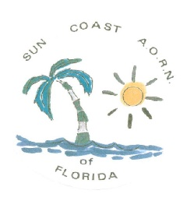

Upcoming Events
January 22, 2026 - AORN Town Hall for Chapter Officers
- 7 pm – 8 pm
January 31, 2026 - Education
Active Shooter & Forensic Collection
- 7:30 am – 11 am
- Der Dutchman Restaurant

February 19, 2026 - AORN Town Hall for Chapter Officers
- 7 pm – 8 pm
February 21, 2026 – (Tentative)
Bowling Social Event
- More information to come!
March 19, 2026 - AORN Town Hall for Chapter Officers
- 7 pm – 8 pm
March 29, 2026 – Board Meeting
- Location/Time TBD

Meet your Board
Angela Shattuck -President
Anna Enander -Vice President
Maria Brigham -Secretary
Lynn O’Melia – Treasurer
Board Members at Large
Jo Arnold
Lori France
Bob Warringer

New Members – WELCOME to the Suncoast Chapter #1011! We encourage professional networking, educational events, and mentoring of our new Perioperative nurses.
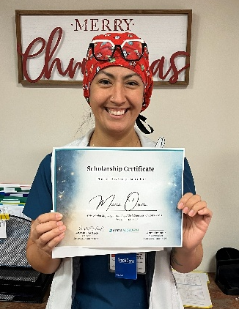
We are excited to announce the first recipient of the 2025 Suncoast Chapter Scholarship Award – Maria Osorio!
Maria has been a Certified Surgical Tech at Sarasota Memorial Hospital for the past 10 years and is currently in nursing school with plans to become a CVOR nurse! The scholarship award will be applied towards her tuition as she completes her degree. Congratulations Maria!
Our chapter awards scholarships each year for Continuing Perioperative Nursing Education. Applicants must be active chapter members or students intending to have a career in the Perioperative field and are student members of the Suncoast Chapter #1011. If you know of anyone who would like to apply for the scholarship, please send us an email, and we will send the application for you to fill out and submit. You can also find the forms on our Facebook page!
Consider supporting our chapter and your hospital by….
- Being an ambassador for the chapter at your work
- Post meeting fliers or host a meeting at your facility.
- Host a chapter-sponsored community support event or networking event.
Find us on Nursing Network: https://suncoastaorn.nursingnetwork.com/
Join our Facebook group –https://www.facebook.com/groups/817391926762509

