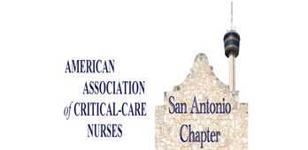  Navigating Kidney Failure When Extracorporeal Devices Collide: Managing the Complications of CRRT and ECMO  January 15, 2026 6:00-8:30 pm  Presented by: Tracee Kennon, MBA, BSN, BS, CCRN  RSVP Required:  https://sachapteraacn.nursingnetwork.com/  http://www.facebook.com/SAchapterAACN/  or scan the QR code below  SAN ANTONIO CHAPTER AACN  Live Dinner Meeting and Education Event  Location: Nonna Osteria  401 S. Alamo St.; San Antonio, TX 78205  Dinner Provided  (Non-member donation- $25.00 – to support conference scholarships; and can be used to join the local chapter for one year, if a member of national AACN) Please note that no shows will be tracked, if your registration is not cancelled twice in 6 months due to being unable to attend, you will be placed on a waitlist for future available seats. Refund for nonmember fee if notified 7 days prior to event with fee utilized for local membership.)  This nursing continuing professional development activity was approved by the American Association of Critical-Care Nurses, an accredited approver by the American Nurses Credentialing Center’s Commission on Accreditation. | Schedule  6p-6:15p registration  6:15-6:30  Dinner Served  6:30-7:00 pm  Vendor Remarks  7:00-7:30p  Chapter Meeting  7:30-8:30p  Education Activity  Adjorn  Register:  sachapteraacn.  Nursingnetwork.com  Dinner Sponsor:  Fresenius  This activity will review the complex interactions in flow dynamics, pressures, and hemodynamics

