
A Pearl, Black, and Gold Affair:
Celebrating Certified Nurses

Dear Valued Vendor/Exhibitor:
The San Antonio Chapter of the American Association for Critical-Care Nurses (SAAACN) is thrilled to invite you to our 12th annual Certified Nurses Dinner Celebration Gala, “A Pearl, Black and Gold Affair,” on March 21, 2026, from 5:30 pm to 10:00 pm at the Marriott Northwest Hotel in San Antonio, TX. This flagship event recognizes the achievements of certified nurses across South Texas. It provides our vendor and exhibitor partners with a unique opportunity to connect directly with over 120 critical care professionals, including frontline leaders, educators, managers, and decision-makers.

Why Exhibit?
Your participation helps promote nursing excellence and increase visibility and access for key healthcare influencers. As a valued vendor or exhibitor, you will receive:
- Face-to-face engagement with over 120 certified nurses and nurse leaders
- Recognition in printed materials, digital media, signage, and social platforms
- Priority exhibit placement based on your sponsorship level
- Banner display opportunities (Gold: front of ballroom, Silver: sides, Bronze: rear)
- Acknowledgment during the event and opportunities for follow-up afterward
- Networking with professionals dedicated to healthcare innovation

Your presence strengthens your brand’s commitment to quality, certification, and collaborative progress in healthcare. We have attached sponsorship options and exhibitor levels for your review. Please confirm your interest and level of participation as soon as possible so we can complete planning and promotional materials. If you have any questions or would like to confirm your participation, please get in touch with Lorri Hays at lorrihays@yahoo.com.

Thank you for considering this meaningful partnership. We look forward to celebrating with you as we recognize the certified nurses whose practice inspires purpose, passion, and progress.

Sincerely,

Dr. Sonya R. Harden, PhD, MBA/MHA, APRN, FAAN
Dean, UT Health, School of Nursing
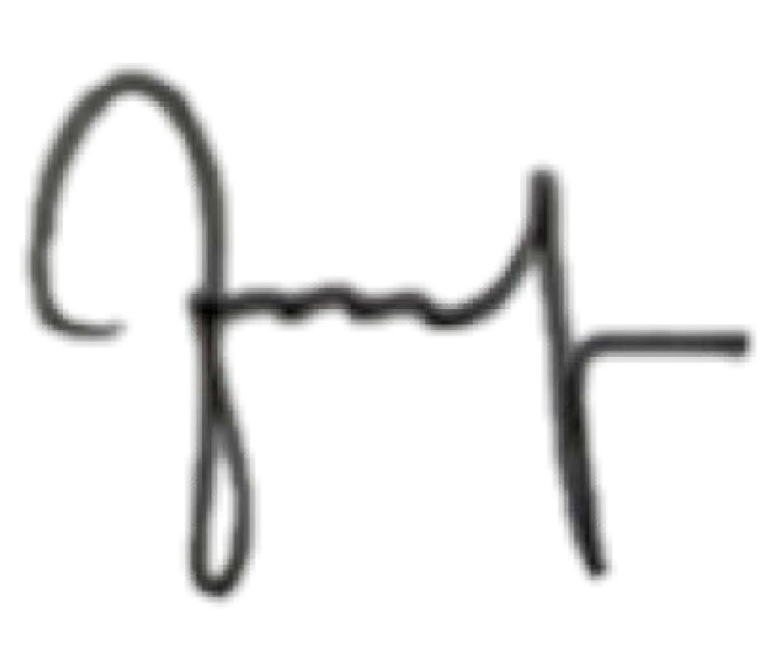

Annierose D. Abogadie, MSN, RN, CPHQ, NE-BC, CCRN, PED-BC
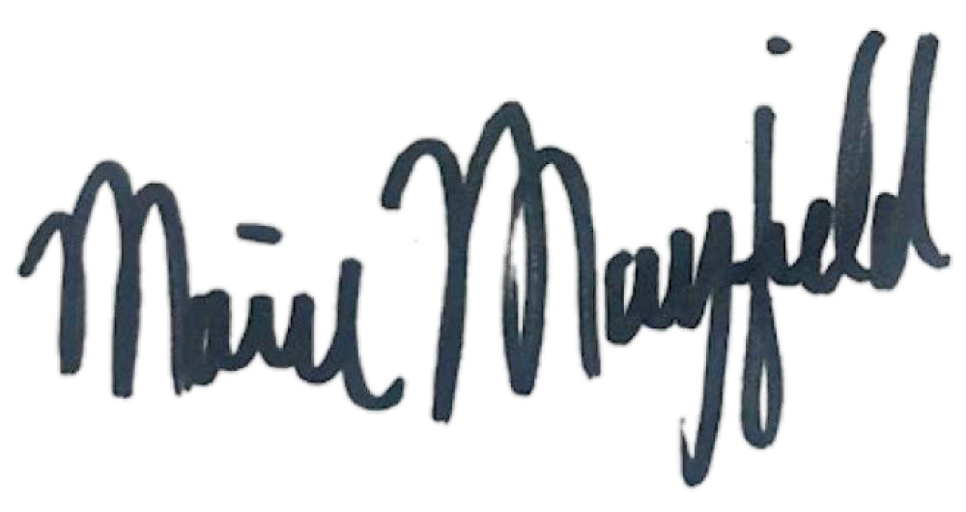
SA-AACN Chapter President

Marie Mayfield, MS, RN, CCRN, CNML
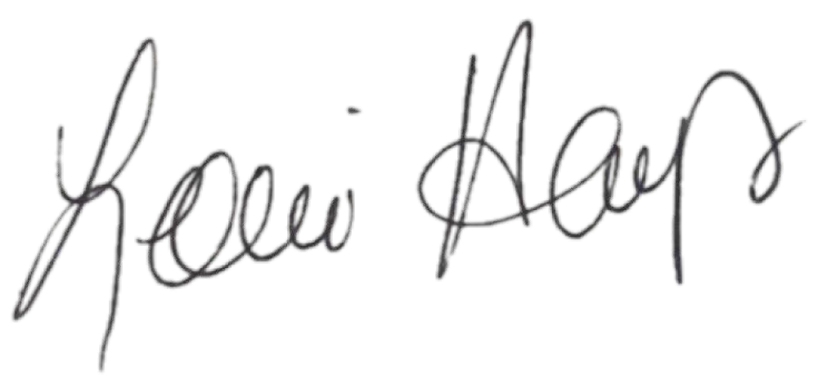
SA-AACN Committee Chair

Lorri Hays, MSN, RN-BC
SA-AACN Committee Chair
Sponsorship Levels
Thank you for considering sponsorship.
Please review the levels listed below and complete your registration online at https://sachapteraacn.nursingnetwork.com or via mail.

Vendor Sponsorship, Certified Nurses' Celebration, March 2026
We highly encourage online registration; however, we also accept checks as a valid form of sponsorship.
We appreciate your support.

____ Gold - $2500
Education Chapter Event hosted by SAAACN.
2 seats for the event
Premium location within the exhibit area with maximum exposure to attendees
Full page, color advertisement in the Program
Logo placed on the San Antonio Chapter AACN website.
Logo placed on all marketing/advertising materials (once payment & logo received)
Recognition in the San Antonio Chapter AACN newsletter – distribution to over 500 members

____ Silver - $1250
2 seats for the event
Preferred location within the exhibit area
½ page, color advertisement in the Program
Logo placed on the San Antonio Chapter AACN website.
Logo placed on all marketing/advertising materials (once payment & logo received)
Recognition in the San Antonio Chapter AACN newsletter – distribution to over 500 members

____ Bronze - $900
1 seat for the event
1 table within the exhibit area.
Logo placed in the Program.
Logo placed on the San Antonio Chapter AACN website.
Logo placed on all marketing/advertising materials (once payment & logo received)
Recognition in the San Antonio Chapter AACN newsletter – distribution to over 500 members

Other sponsorship opportunities include the following items. The name will appear in the print materials.

___ Gift Cards ($50) ___ Sponsor a group of 4 Certified Attendees ($250/group)

___ Door Prizes ___ Gift Packs to Attendees ($450)
(Company Merchandise)

Name of Organization/Company/Agency: _________________________________________
Contact Person: ____________________________________________________________
Address: __________________________________________________________________
Email: ____________________________________________________________________

□ Make Check Payable to: San Antonio Chapter of American Association of Critical-Care Nurses—mailing address: 332 Waterstone Pkwy, Boerne, TX 78006.

For more information, contact:
SAAACN at https://sachapteraacn.nursingnetwork.com/contact

