The Monitor
American Association of Critical Care Nurses
Greater Milwaukee Area Chapter

2025-2026
Board Members

President: Jaime Uecker
Vice President & Education Co-Chair: Terra Marr
Treasurer: Samantha Hendricks
Treasurer-Elect: Sherry Scott
Secretary & Membership:
Lauren Evenson Carroll
Social Media & Outreach:
Jackie Klotz

OPEN Elect Positions:
President-Elect
VP-Elect
Secretary/Membership-Elect
Social Media/Outreach-Elect

Inside this issue
Message from Jaime 1
Open Board Positions 1
Upcoming Events 2
NTI Scholarship 2
Treasurer’s Report 3
Education Committee 3
Membership & Secretary 4
Social Media & Outreach 4

Message from GMAC President Jaime Uecker

As another year comes to a close, I want to take a moment to reflect on the exciting opportunities and growth within GMAC this fiscal year. We continue to expand our in-person educational offerings and were thrilled to explore new learning experiences at the Hot House in Menomonee Falls.

We currently have several elect positions open and encourage members to consider getting involved. Elect positions provide a valuable opportunity to learn the role for a full year before officially stepping into it. Benefits include free membership, NTI-related perks, and meaningful leadership development. If you are interested or have questions, please reach out to any board member—we would be happy to support you.

Looking ahead, NTI 2026 will be held in San Diego, and scholarship opportunities are opening up. We were excited learn more about our artwork and theme as we prepare to continue to focus “On Purpose.”

Lastly, and most importantly, thank you for standing strong with GMAC. While many chapters are experiencing challenges, our chapter continues to grow, and we are deeply grateful for the commitment and support of our members. We are fortunate to have such an engaged and dedicated community. Let’s continue to build our Board and move forward together, doing great things for the nursing profession.

Jaime Uecker
GMAC President

Open Board Positions
If you are interested in any of the open Elect positions below, please contact us through a GMAC contact form (See "Contact Us" on the banner to the left of the Nursing Network Website).

Available Elect Positions
President-elect | Vice President-elect | Volunteers for education committee
Secretary / Membership -elect | Social Media / Outreach-elect | Volunteers for education committee

Monitor Distribution | Educational Sessions | General Board Meetings  2nd Tuesday of the month
March 2026  June 2026  September 2026  December 2026 | Next Session TBD-  likely February & April | February 10th 2026  April 14th 2026  June 9th 2026
Time & Location: | Varies by Month & Location | 7PM start  Virtually – Google Meet

NTI 2026
San Diego, CA May 17-20 2026

Registration Rates NTI 2026 Conference - AACN
Date / Rate | Member | Non-Member
Early Bird (until Feb 2) | $700 | $895
Advanced (Feb 3-Apr 6) | $830 | $1025
Regular (Apr 7-May 17) | $895 | $1090

Hands-on learning, Inspiration, Togetherness.
Nothing can replace the energy and sense of belonging that comes with an in-person NTI. Motivational keynotes set the tone for three days overflowing with new experiences. At NTI, you’ll enjoy time away from work learning and networking with leading experts in critical care and colleagues from across the country.

Scholarship Opportunity to attend NTI 2026
GMAC is giving away a scholarship to assist with cost to members who wish to attend NTI 2026. If you are interested, please submit the NTI Funding Application Form to milwaukeeaacn@gmail.com by February 20th, 2026. The scholarship application is a short essay (1000 words or less) on how attending NTI will impact your nursing practice. Recipients will receive up to $1,000 toward the cost of NTI with proof of enrollment/airfare/lodging.

Our chapter is investing in the education of our members. We have supported attendance at NTI for scholarship recipients & Board Members. In addition, our current funds have enabled us to provide past Nurses’ Night Out educational meetings with speakers, food, and drinks. We thank you for attending these events, and hope they inspire you to continue your membership with our strong AACN chapter!

Samantha Hendricks - Treasurer Sherry Scott – Treasurer-Elect

North Shore Bank Accounts:
Checking Account: $4,617.95 Savings Account: $30,511.67

Our December 2025 Session was a presentation on Spinal Cord Injury Prevention in Thoracic Aneurysm Repairs by Maria Wellenstein APNP & Laura Needler APNP. This was followed by a round-table where Board Members who attended NTI 2025, as well as our scholarship winner Geri Aurora, shared their experiences & the benefits of attending the conference.
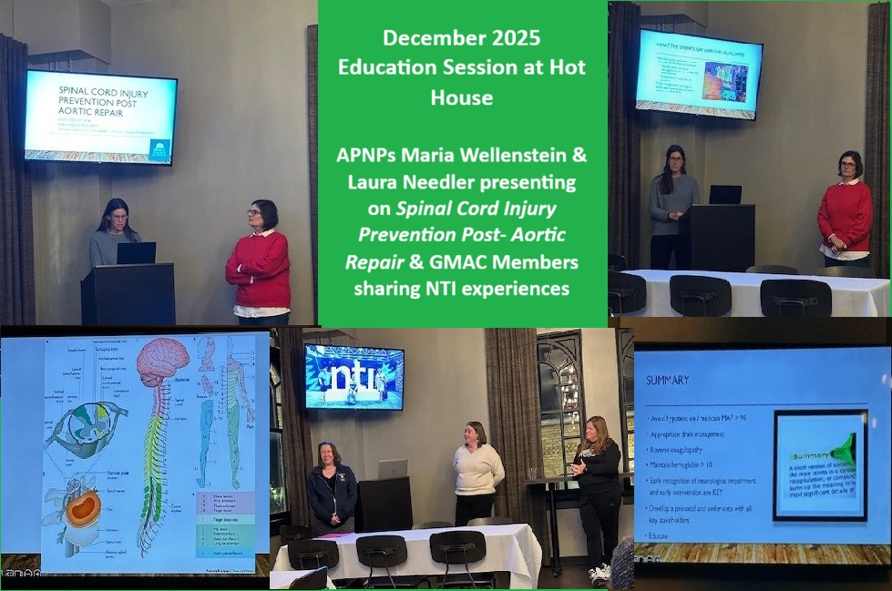

If you are interested in helping plan future education sessions, please contact Terra Marr (tmarrrn@gmail.com)

Membership
Current Membership: 67 (5 new members & 23 renewals in past 90 days)
A few membership housekeeping reminders:
- AACN membership is required for any GMAC membership
- GMAC annual membership is $37, students $10
- Non membership fees individual session fees TBD
- New and renewing memberships can be completed on the GMAC website at https://milwaukeeaacn.nursingnetwork.com/
- Print membership cards from https://milwaukeeaacn.nursingnetwork.com
- Please share with colleagues about this amazing professional nursing organization!
- Changes to Bulk Membership: Click HERE for details
You can reach out to any current board members for additional information. If you have specific Membership questions, please contact Lauren Evenson Carroll (lauren.evenson@gmail.com).

Visit

https://milwaukeeaacn.nursingnetwork.com

to see updates on meetings, education offerings, & events.

Find Us Here on Social Media

 |  |  | 
milwaukeeaacn @gmail.com | AACN_GMAC | @AACN.GMAC | MILWAUKEEAACN.  NURSINGNETWORK.COM

Ambassadors
GMAC continues to look for hospital ambassadors to assist with membership, outreach, and chapter education at your hospitals. If you are interested in hearing more about what these positions entail, please reach out to Jackie Klotz or Lauren Evenson Carroll via Nursing Network. Lauren has met with the leader over Nursing Recruitment & Retention at Froedtert Hospital to discuss improving the promotion of nursing involvement in professional organizations, including AACN & GMAC within the hospital.

Outreach

We continue to look for opportunities to serve our healthcare professionals and community alike during these trying times. If you have an outreach opportunity that you would like to share with GMAC, please reach out to us through our contact page on Nursing Networks. We would love to hear from you.

 Upcoming Events & NTI Scholarship

Education Committee

Treasurer’s Report

Social Media & Outreach

Secretary & Membership

