MASPAN Board of Directors ZOOM Meeting Minutes
November 15, 2025
7:30 am-12:00 pm

ATTENDANCE: Christine A. Fournier Bell, Meg Beturne, Erin Cole, Donna Constant-Haley, Anne Halliday, Christine Hill, Stephanie Johnson, Kathryn McCarraher, Maureen McLaughlin, Suzanne Russell
EXCUSED: Jodie Dill, Melissa Lewis, Allison Popa
GUESTS: Josette Renda

Meeting called to order at 7:33 a.m. by President/ Chair Suzanne Russell Timekeeper: Erin Cole

TOPIC | DISCUSSION/RECOMMENDATIONS | ACTION/ASSIGNMENT | FOLLOW- UP/ RESOLUTION/DATE
Welcome & Updates | Welcome and Introductions  - Suzanne read an e-mail from Jodie Dill who will be stepping down as a BOD. There was a discussion of gratitude and appreciation of Jodie’s involvement on the BOD and past presentations at MASPAN conferences. The BOD wishes her the best of luck in the next chapter with her family.  - Suzanne welcomed Josette Renda as a guest with interest in being a BOD. She works at Mass General ambulatory Day Surgery as a manager and has expressed an interest in helping with conferences, vendor recruitment and networking. She is actively encouraging staff to become certified.  - Current BOD members introduced themselves and shared their respective roles within MASPAN | None  Josette will join the BOD as a Member at Large and added to the Education Committee.
Minutes:  June  September | - The June minutes were reviewed and approved via e-mail in July and posted to the MASPAN Website shortly after  - A special BOD meeting was held on September 30th to discuss a possible merger with RIPAN with Ursula Mellinger, ASPAN President  - An AI Summary of the meeting was sent out but needs to be revised into Minute format | None  Ali Popa is working on the Minutes and will send them out shortly | Ursulla Mellinger, ASPAN President has since shared with Suzanne that the possible merger is no longer necessary due to legal aspects of RIPAN and that they have not had Articles of Incorporation since 2018
New Business | - Review of Donna’s e-mail – (See Appendix 1)  - The MASPAN domain is registered with Go Daddy until 11/2029. It is currently on Donna’s credit card which will need to be renewed in 2027.  - Patty has offered her card as a backup and will have her husband who works for a non-profit to look into the use of a debit/credit card.  - MASPAN Zoom Registration will be increasing in 2026 from $149 to $159.  - Discussion about the use of ASPAN Zoom vs MASPAN Zoom | Maureen will investigate having a MASPAN Debit card.  MASPAN will keep their Zoom account for 2026 and then address again in Fall 2026 | Follow up the June 2026 BOD meeting.  Follow up at Fall 2026 BOD meeting
Board Transitions | - The President and Vice President positions will transition at the end of March 2026.  - Thank you to Suzanne who has fulfilled the role of President for 3 years (allowing additional time to mentor Erin) | - Erin will become President in March 2026  - Melissa will become Vice President/President-elect in March  - Maureen transitioned to Financial Director in March 2025 but because of geographical distance, the physical transition occurred in June.  - Chris Hill, former Treasurer, will continue as a check signer and remain as a member of the Finance Committee  - Maureen, Suzanne and Chris Hill are check signers right now. | Erin to follow up with Maureen to become a check signer as the MASPAN President
PDI Updates | - Suzanne, Erin, Stephanie, Maureen and Ali attended in person with Melissa attending virtually.  - Erin reported there was good dialog and conversation. there are still many unanswered questions about ASPANs reorganization proposal.  - Suzanne and Ali are members of the Executive Oversight Committee (EOC) who have had 42 meetings since July discussing the proposed reorganization. There is a follow-up EOC meeting on 11/18 to discuss the concerns from PDI.  - Maureen reported that the hallway conversations and networking were positive. There are a lot of future unknowns at this time with lens on component growth. She felt that the message was the individual components are done, here’s the future/  - Suzanne reported that ASPAN is on a time constraint and will require representation from every geographical area and state. Each region will need a lead person in their area and state with policies and templates.  - Stephanie reported that the Region Directors were not initially members of the EOC and PDI was where they first heard about. The EOC SWOT has been a huge time commitment. The proposal does include representation from every state in each region.  - General discussion among the BODs about the value of MASPAN membership and the fact that we have many members and active BODs. We have the ability to mentor and encourage our members to be engaged without being on the BODs. We have an opportunity to be proactive and learn from the regions that have already merged to improve the process. | Suzanne will send a list of questions to ASPAN Leaders as well as continue to forward e-mails from ASPAN with updates. | Continue to watch ASPAN updates.
Region 4 Update | - Stephanie is the Region 4 Director until 2028.  - There is a new ASPAN CEO Pete who has a successful past with organizations, great ideas and listens.  - ASPAN Budget discussion included the need to invest in improving the ASPAN Website and technology upgrades. There has been an increase in social media presence with actual pictures of members instead of stock pictures which people appreciate.  - Region 4 has held 2 certification study groups for which attendees are appreciative. This has been a significant time component for Stephanie where she has had to commit to every Wednesday night for 6 months. The certification study groups will be changing to a national format offered twice weekly for different time zones.  - ASPAN board meetings will now be held every other month, virtually plus three in person meetings.  - The 2026 Candidate Profiles are available on the ASPAN website. Ali Popa is a candidate for Director of Clinical Practice | - Steph is always available by cell or email with any questions or concerns.  - Be sure to vote for the candidates by 2/28/2026
Committee Reports: | Mayflower Newsletter – Stephanie Johnson  - Stephanie shared her appreciation for the contributions of articles.  - A Nov/Dec issue is planned.  - Will need 4 issues in 2026 to apply for Gold Leaf in 2027  Research/Clinical Inquiry – Christine Bell  - At the MASPAN Fall 2025 Conference there were 8 posters displayed with 3 posters chosen for presentations. BIDMC had 2 presentations.  - Chris recommends that we extend the invitation to all Region 4 members to display at future conferences.  - The ASPAN Clinical Inquiry Committee is the process of rewriting the Research Primer to include a new section on Innovation.  - Chris will have 2 presentations at National Conference  Governmental Affairs – Anne Halliday  - Anne attended the ANA Massachusetts Lobby Day at the State House on Sept 30th – unfortunately Patty was unable to attend due to Jury Duty.  - The event focused on three bills, with the Surgical Smoke Bill being a major focus.  - “Tips of meeting with Legislators” was offered and included discussion about being on time, having a story to share but staying on topic and being respectful of their time.  - Anne shared her walk around the State House, which is beautiful, especially the brass plaques and the Hall of Flags  - Karen Spillka, Senate President, reported that 2,000 nursing students have registered for free tuition at two-year schools in MA.  - Anne will have a full report in the upcoming issue of the Mayflower newsletter.  Membership/Marketing – Erin Cole (See Appendix 2)  - Membership is down.  - Membership increases around Certification Review Courses and Conferences  - There are new members and then members who renew after a 3+ year gap renew to renew certification fees possibly due to lower recertification fees as a member.  - Maureen proposed a Membership Drive and identify a “Recruiter of the Year 2025” for MASPAN  Scholarships and Nominations: Suzanne Russell for Melissa Lewis  - Donna suggested guidelines for the Shining Star Award, as we have none at this time and it is not on the MASPAN Website.  Social Media:  - Melissa continues to be responsible for FB and Instagram, posting pictures and information.  Website -Donna Constant-Haley  - Pictures from the Fall Conferences are on the website.  - By-laws have been posted to the website.  - Donna has reviewed Affini Pay with Maureen | Continue to send articles and pictures to Stephanie.  - Anne and Patty will continue on Governmental Affairs and plan to attend the 2027 Lobby Day  Plan a Membership Drive for December with 2 $50 Amazon Gift Cards raffled to new and 3+ year gap new members.  Erin will reach out to Eileen Ziegler at ASPAN in January to identify the MASPAN 2025 Recruiter of the Year  The Shining Star Award will be placed on the MASPAN website with a simple nomination application – (By whom)  Reach out to Melissa is interested in being on the Scholarship Committee  - Continue to send pictures to Donna, Melissa and Stephanie with names of people.  - Donna will continue to manage the MASPAN website and welcomes any assistance. Please let Donna know if you are interested.
 | Financial Report – Maureen McLaughlin  (See Appendix 3)  - 11/13/2025 Bank Balance $39,112.58  - 12/2024 Bank Balance $30,078.49  - Members financially benefited with $3500 spent on Standards, Ready-Reference Cards, Grants and Scholarships  - The MASPAN Website only shows income and does not include refunds.  - The AffiniPay fee for conference registration is locked in.  - Zoom fees include monthly usage to allow for muting of attendees for conferences.  - KUDOS to Melissa for obtaining Vendors for the Fall Conferences  - AACN Contact Hour application fee has increased to $160.00 per application.  - Due to the bank balance, Suzanne proposed funding two additional BODs for the 11/2025 PDI – 2 nights hotel and registration for a total of $610 each.  - Maureen initiated a discussion about MASPAN monies going to an ASPAN Legacy Fund if components merge.  She proposed giving back to our members.  - Meg expressed concern about spending too much money and keeping MASPAN viable and successful.  Education – Kathy McCarraher  (See Appendix 4)  - 5 Conferences were held in 2025 with 25.5 Contact hours offered.  - The MASPAN CPAN & CAPA Certification Review Course scheduled for 9/20/2025 was cancelled.  - CE application is good until Spring of 2026  Waltham Woods Fall Conference 10/4/2025  - 59 attendees – positive evaluations!!  - 8 Presentations by MASPAN BODs  - 9 Posters displayed with 3 chosen to present  - 6 Vendors and 1 Jewelry Vendor – thank you to Melissa and Donna  - Shining Star Award, Standards Book, Free conference awarded.  - 6 - $25 Amazon Gift cards given to Poster Presenters  - Great venue and delicious food  - Chris Bell shared a story about networking at lunchtime with an Endoscopy Nurse who was a new attendee and grateful for the conference.  Holyoke Fall Conference 11/1/2025  - 23 attendees, which included 7 BODs and 4 Speakers  - 4 Presentations  - Positive evaluations and appreciative attendees  - Easy access off highway, nice venue and AV Support  - 2 $25 Amazon Gift cards to Presenters and 2 $50 Amazon Gift cards to Presenters  - Raffles: Coffee Basket donated by Meg and 50/50 raffle  - Thank you to Meg, Stephanie and Patty for being the Hosts.  PANAW 2026 Virtual Presentation 2/4/2026:  - “Herbal Supplements and Anesthesia: The PeriAnesthesia Nurse’s Role in Surgical Preparation” by Ursula Mellinger, ASPAN President  - This will be free for MASPAN members.  CPAN and CAPA Certification Review Course – 2/7/2026  - Maureen will present.  - Registration Fees to be $40 for MASPAN Members, $50 for ASPAN Component Members and $99.00 for Non-ASPAN Members  Spring Conference 2026:  - ½ day virtual date discussion with the reminder that Palm Sunday, Easter and NC are around the same time.  - Kathy suggested April 11^{th.}  Evaluations:  - Each conference evaluation includes a section on type and time frame preference, which shows a strong preference for in-person conferences over virtual formats. | The Financial Report was accepted by the BODs  - The BOD unanimously agreed to fund Maureen and Ali for PDI expenses.  - The BODs unanimously agreed to  - Significantly decreasing 2026 conference fees  - BODs attending virtual conferences for free.  - Creating a Humanitarian Grant instead of a Scholarship for $1000.  - Increasing the National Conference Scholarship from $1000 to $2000  - Funding 2 additional BODs if 2 are funded by their institution to attend RA.  - Maureen will reapply for CEs for 2026  - Kathy recommended that we continue to use Waltham Woods for our Live Full Day Conference  - Suzanne will reach Waltham Woods for 11/14/2026 date.  - Kathy recommended that we continue to offer a Fall Conference at the Baystate Health Education Center in Holyoke  - Patty will check availability for 10/3/2026.  - Meg has ideas already.  - Conference planning will start after the Spring 2026 Conference  - Donna will post on the website after discussing with Kathy registration dates.  - Donna will post on the website after discussing with Kathy registration dates.  - Kathy will plan an Education Committee mtg in early January. Please forward any speaker ideas to Kathy | Maureen will obtain the AZPAN Humanitarian Grant Policy from Katrina Bickerstaff  - Shortly after MASPAN’s BOD mtg, VT/NH sent out a flyer for their April 11th LIVE Full Day Conference. Kathy, Suzanne, Erin and Donna communicated and have changed the Spring date to Saturday, March 21st. Kathy to begin recruiting speakers and plan a brief Zoom mtg in early December to update the Education Committee on progress. CE application will need to be submitted by mid-January at the latest.
By-Laws | Discussion led by Suzanne Russell  Crisis Manual:  - We do not have a formal Crisis Manual. The BODs discussed the need for both hard and electronic formats of a Crisis Manual  By-Laws:  - Have been posted on the MASPAN Website  - Will need to have updated dates for Gold Leaf application | - Will need to explore options for creating a Crisis Manual with secure access.  - Suzanne and Erin will work on updating the Bylaws regarding the disposition of funds. | Continued discussion at June BOD meeting.
Gold Leaf | Discussion led by Maureen McLaughlin  - MASPAN Not eligible to apply until 1/21/27 to reflect 2026. | - Maureen will work with Stephanie to ensure that we will be ready for Gold Leaf
Succession Planning | Discussion by Meg Beturne  - Will revisit in June when we know what is happing with ASPAN.  - It is important to have a succession plan for each role and mentorship is essential.  - Maureen recognized Meg for recruiting members. |  | Further discussion at June BOD meeting
Open Discussion | PANAW –  - The board will continue with traditional PANAW week activities: $1 lottery tickets, letter, free evening presentation for members and a raffle for the April Conference  - PANAW letters – Suzanne will create, it is time consuming to fold, stuff, label and stamp.  Important Time Frames:  - Financial – calendar year  - State Filing – March  - Taxes – November  FOOD Drive Initiatives:  - Maureen proposed a Food Drive Initiative for the months of November and December.  - Maureen has an article for the Mayflower about “2 months of giving” to address food insecurities.  - Patty shared how her grocery store makes it easy to donate food at checkout.  - Meg described the Grey House in Springfield that serves 1,5000 weekly.  ASPAN Merger continued discussion:  - How should MASPAN communicate with members about the ASPAN reorganization without having complete information?  - How will ASPAN ensure representation from all states in the Region if reorganization occurs?  - How is ASPAN maintaining member engagement during a period of uncertainty?  - How will transitioning of individual component websites be managed and how to share responsibilities to keep updated?  - Will there be an ASPAN Crisis manual that has templates, guidelines and policies? | - Donna will purchase NH lottery tickets.  - Maureen will purchase MA lottery tickets.  - Kathy will work with Suzanne to get the PANAW letters ready.  - Maureen will create e-mail blasts to encourage individual food donations.  - MASPAN members will be encouraged to share photos of their donations.  - Suzanne will draft a letter to ASPAN with our continued questions and share with the BODs prior to sending

Meeting Adjourned at 12:03 pm
Next Meeting June date TBD
Respectfully submitted by Kathy McCarraher, MHA, BSN, RN, CPAN

Appendix 1
Donna’s Items

These are agenda items for the November Board Meeting
1. Website: The domain name for maspan.org will expire on November 11, 2029. At this time, it has my credit card on file with GoDaddy. It also has my email to get notifications and mailing address on file.
I would like this changed to someone elses card and information or we get a MASPAN credit card and decide which position carries this information.
2. The annual MASPAN Pro plan Zoom bill will come in February, it is $149.00 and they have notified us that it will be $159.00 for next year. This will include AI technology. Don is planning to test AI technology this week-October 13-18, 2025, so I will have more updates on this.
2. Share communication that Stephanie will be providing the zoom links for our November meeting and any/all future if she prefers. She has free access to zoom with AI technology from ASPAN.
3. All photos from the Waltham Fall conference and Shining Star presentation are posted on the website. 4. On October 8th I updated our complete MASPAN membership from ASPAN to the MASPAN website. When we send a blast, we have 1,867 recipients and 325 active members who receive the blast notices.
5. I would like to suggest a policy or guideline for the Shining Star award. The Shining Star is recognition for an ASPAN component for supporting and encouraging CPAN & CAPA certification at the local level. (In 2018 the MASPAN board decided rather than store many Shining Star awards we would pass them along to a deserving certified MASPAN member. Since that time the entire BOD has been included in the being aware of a nomination and often there is only 1 nomination. More importantly there is an opportunity for each board member to make a recommendation as a response to an email inquiry or discussion at the November Board meeting, for possible presentation during PANAW week. We have given the Shining Star award at the Fall conference in Waltham but only after a board discussion and electronic vote.
The shining star award is a cumulation of ALL of the boards work regardless of or if they are working clinically in a leadership role or not. Including everyone would allow for transparency and inclusion.)
6. The By-Laws once completed will be sent to ASPAN and posted on the website. I will not send them out to all MASPAN members again, only a notification that they are completed and posted on the website. There has been no response from any member after sending out the markups.

Appendix 2
Membership Report – Erin Cole

Membership update 11/15/2025
- 344 active members as of Nov 1, 2025. Down 13 members June 2025 BOD meeting (357). Stayed the same for October and November
- 36 new members June-Nov 2025.
- 13 are certified CPAN or CAPA and 0 is Dual certified. 4 have other specialty certifications.
- Highest month of new members- was September 2025 with 11.
- Highest month of renewals was September 2025, with 29 renewals.
- Highest month non-renewal was October 2025, with-12 Renewal letters sent each month.
- 11 members renewed the following email request for renewal.
- As of 11/11/25- 3 new members joined 8 members renewed. 10 members expiring this month.

Appendix 3
Finance Report – Maureen McLaughline

2025 MASPAN END OF THE YEAR (partial) FINANCE REPORT
November 13, 2025 Asset: $39,112.58 Dec 2024: $30,078.49)
Outstanding:
- AV, food & beverage for Holyoke ($592.75)
- Deposit of $175 from Holyoke raffles
- PDI X 2: hotel, per diems, etc (hotel estimated $$515.38 X 2)
- PDI on-line registration ($25 x1?)
Income $30,340.50
Expenses $20,451.20
//////////////////////////////////////////////////////////////////////////////////////////////////////////////////
Income
- Membership Jan-Oct $8820 (N=294)
- Conference registration(s) $15,520.50
- Vendor support $6000
$30,340.50

- Holyoke $706 (N=21)
- Waltham Woods (-$30 refund) $7570 (N=61)
- April virtual (-$262 in refunds) $3936.50 (N=74 ~3 pd by check)
- PANAW (free) $100 ( N=102)
- Certification review $3208 (N=24)
//////////////////////////////////////////////////////////////////////////////////////////////////////////////////
Expenses

Nursing network/Affini pay fees (registration fees) $947.50

Member benefits (raffles, prizes, grant checks, PANAW) $3538.04

- Standards X 2, redi-ref X 2) $338
- Grant checks NC $725
- PANAW $944,99
- Scholarship X2 (ICPAN, scholastic) $1063.61
- NC meet and greet $336.44
- Free conference raffle (WW) $130
Donations $690.38
- Red Cross $250
- ASPAN NC support ($1 per member) $400
- Silent auction $40.38

Zoom Fees $1067.90
- Annual fee $159.90
- Certification Review $500
- Spring $250
- Usage fee X 2: Feb, March $158
Governance $3942.01
- NC funding $2814.07
- PDI (to date)
  - Registration X1 $95
  - Airfare X2 $1032.94
  - Pending…..
Education $8220
- Waltham Woods $6000
- Speaker fee
  - Certification review $1000
  - April X4 $600
- Contact hour application fees
  - PANAW $150
  - Spring $150
  - Fall $160
  - Holyoke $160
$620
Amazon gift cards $300
- Fall poster presenters $150
- Holyoke speakers $150
Gifts $151.87
- Sympathy wind chimes $151.87
Paper statement fees
- $3.00 monthly $30
Postage, checks, printing, other $1563.50
- Maureen stamps, envelopes etc $40.19
- Postage raffles, stamps $35.30
- Checks $81.35
- Cert review printing $1066.67
- Postage cert review $269.70
- Stamps $36.30
- Binders $33.99
$1563.50 Expenses $20,451.20
Board member benefits
- Free conference registration $1130
- Reduced $330 /////////////////////////////////////////////////////////////////////////////////////////////////////////////
Education Summary
Certification Review
Income (N=24) $3208 (+ $292.63)
Expenses
- Binder printing $1066.67
- Binder mailing $269.70
- Zoom host $500
- Speaker fee $1000
- Zoom February fee $79
$2915.37
PANAW Week (- $50)
Income (free conference) $100
Expense
- Contact hour fee $150

MASPAN Spring Conference March 24, 2025
Income $3936.50 (+2857.50)
Expenses
- Zoom host $250
- Zoom fee $79
- Contact hour fee $150
- Speaker fees $600
$1079

Waltham Woods Fall Conference
Income $13,570 (+$7260) ***$6K deposit 2024)
- Registration $7570
- Vendors $6000

Expenses
- Waltham Woods $6000
- Contact hour fee $160
- Amazon gift cards $150
$6310

Fall Conference Holyoke
Income $706 (-$186.75)

Expenses
- Amazon gift cards $150
- AV (pending) $339
- Food & beverage $253.75
- Contact hour fee $150
$892.75

Appendix 4
Education – Kathy McCarraher

Date/Time | Title | Virtual/Live | Speakers/Topics | # CEs | Attendees
2/1/2025 | MASPAN CPAN & CAPA Certification Review Course | Virtual | Maureen McLaughlin, MS, RN, ACNS-BC, CPAN, CAPA | 8 | 22
2/5/2025 | Peri Anesthesia Care in the Non-Operating Room Setting | Virtual | Lori Silva, MSN, RN, CCRN, CPAN  ASPAN 2024 – 2025 President | 1.25 | 76
3/29/2025 | MASPAN Spring Conference 2025 | Virtual | 4 Presentations  Topics to consider:  - Legal issues of Documentation – Katrina Bickerstaff - Confirmed  - Periop Optimization – Terri Clifford - Confirmed  - Plastic Surgery – Dr. Ng Glazier - Confirmed  - Massive Transfusions – Kaitlin Bolster | 4.25 | 76
5/2024 – 4/30/26 | The Impact of Surgical Positioning on Post Anesthesia Patients | On Demand | Stephanie Johnson, MSN, RN, CPAN, CAPA  (10 have viewed thus far) | 1
9/20/2025 | MASPAN CPAN & CAPA Certification Review Course | Virtual | Maureen McLaughlin, MS, RN, ACNS-BC, CPAN, CAPA | 8 | Cancelled  8/22/2025
10/4/2025 | MASPAN Fall Conference 20025 (Full Day) | Live – Waltham Woods | 8 Presentations by BODs:  - Pediatrics, Negative Pressure Pulmonary Edema/ Ventilator Management, Nursing Innovation, Laparoscopic Surgery, Clinical Practice Frequently Asked Questions, Humanitarian Nurses Journey, Aromatherapy, Celebrating Successful Practices  6 Vendors and 1 Jewelry  9 Posters  Awards | 6.75 | 61 registered, 59 showed
11/1/2025 | MASPAN Holyoke Conference (1/2 Day) | Live – Baystate Health Education Center, Holyoke | Meg/Stephanie/Patty hosted  - 4 Presentations – Anesthesia Emergencies, Aromatherapy, Pain, Holistic Nursing | 4.25 | 23 includes  7 BODs and 4 Speakers

Waltham Woods Summary
- 61 Registered/59 attendees
- 7 Vendors and 1 Jewelry Vendor
- 9 Posters displayed with 3 chosen for Successful Practices presentation – 6-$25 Amazon Gift cards
- 8 Presentations by Board of Directors
- Separate time for Celebrations and Awards
- Raffles: Standards Book, free conference, jewelry piece
- Continental Breakfast and Lunch
- Overwhelmingly positive evaluations!
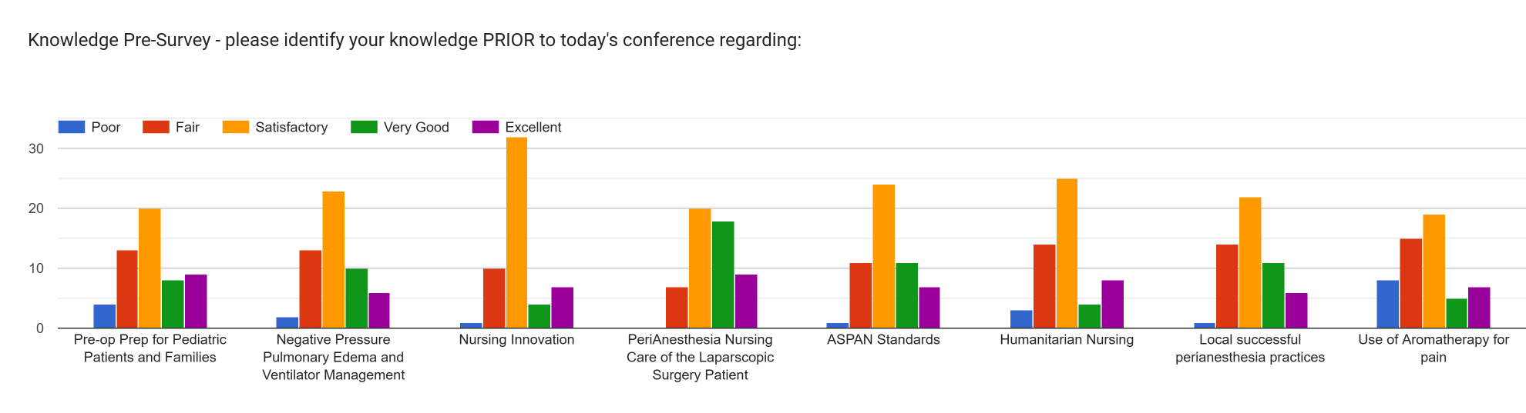
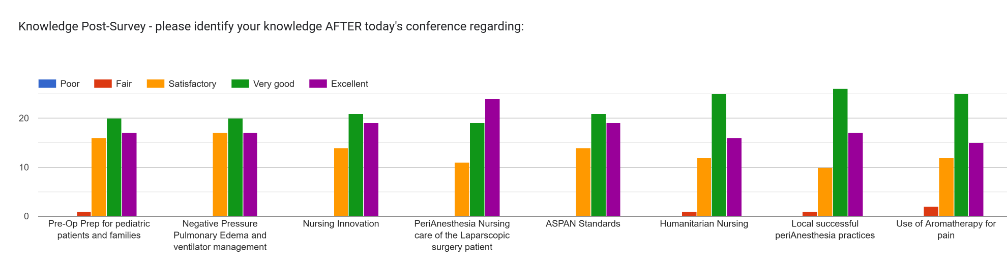

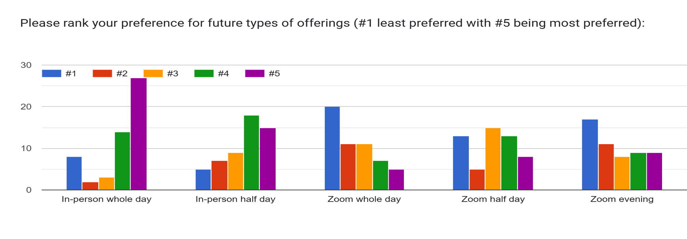

HOLYOKE Conference Summary:
23 Attendees
4 Presentations ( Amazon Gift Card Honorariums – 2- $50 and 2- $25)
50/50 Raffle
Coffee Gift Basket Raffle – Donation by Meg
Continental Breakfast
Evaluations were positive and appreciative

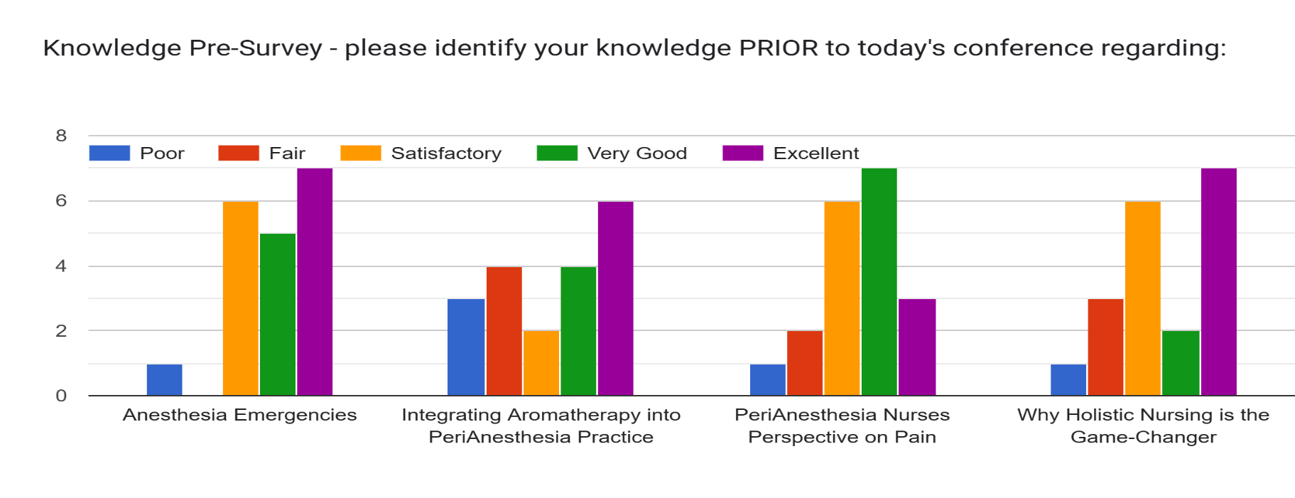

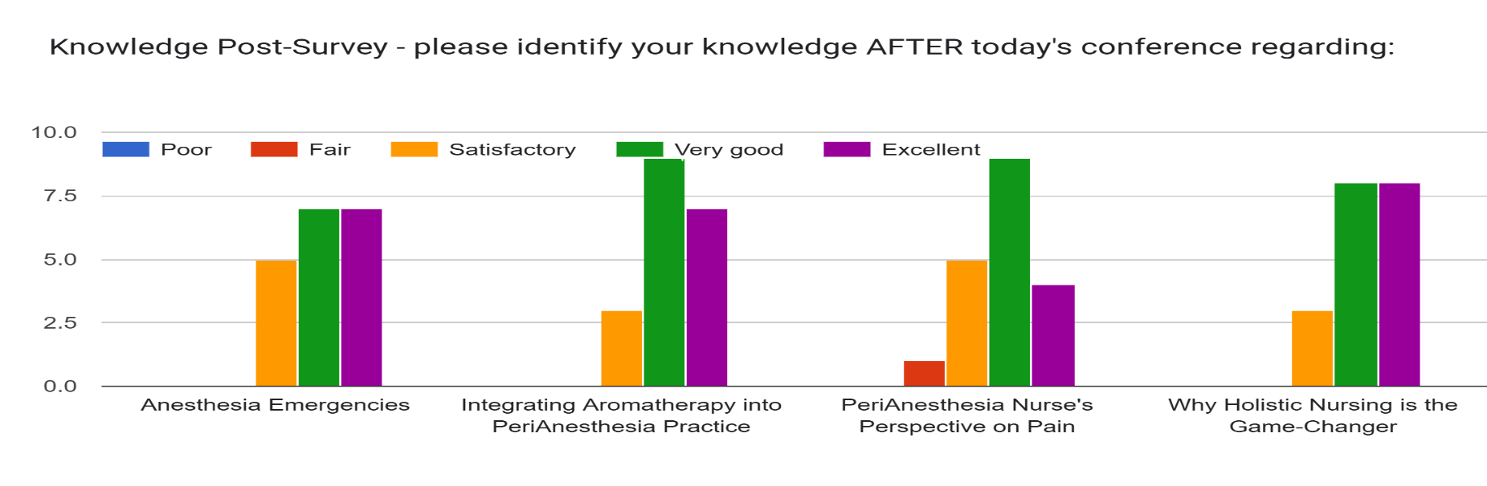

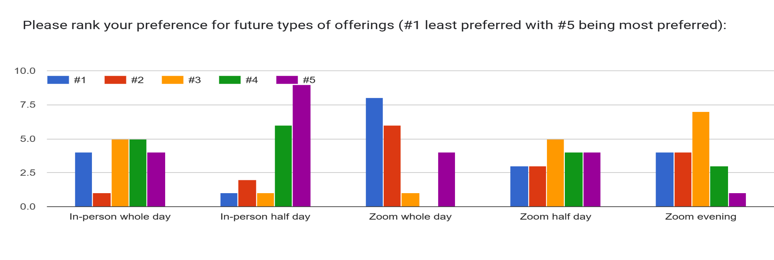

Proposed 2026 Educational Offerings
Date/Time | Title | Virtual/Live | Speakers/Topics | # CEs | Attendees
2/4/2026 | Herbal Supplements and Anesthesia  (Confirmed) | Virtual  Evening | Ursula Melllinger, BSN, RN, CPAN, CAPA  ASPAN 2025 – 2026 President | 1.25
3/14/2026/  3/7/2026 | MASPAN CPAN & CAPA Certification Review Course  (Confirmed) | Virtual  Full Day | Maureen McLaughlin, MS, RN, ACNS-BC, CPAN, CAPA | 8
March/April  (3/29 Palm Sunday, 4/5 Easter, 4/20 week School vacation,  4/27 –4/ 30 National Conference) | MASPAN Spring Conference 2026  April 11th (NH/VT Conflict)  March 21, 2026 | Virtual  (1/2 Day) | - Suzanne’s MD - ?Holding Meds  - Melissa – Colorectal Surgeon  - ? Cannabis – Donna’s contact  - ? Geriatrics | 4.25
Expires 4/30/26 | The Impact of Surgical Positioning on Post Anesthesia Patients | On Demand | Stephanie Johnson, MSN, RN, CPAN, CAPA  (14 have viewed thus far) | 1
? Fall | MASPAN CPAN & CAPA Certification Review Course | Virtual  Full Day | Maureen McLaughlin, MS, RN, ACNS-BC, CPAN, CAPA | 8
? Oct 3rd | MASPAN Holyoke | LIVE  (1/2 Day)  Holyoke |  | 4.25
(? 11/14)  PDI (11/7 – 11/8) | MASPAN Waltham | LIVE  Full Day  (Whole day) | Legal  Cidalia: Aromatherapy and or Impact of Disruptions | 6.75
 |  |  | TOTAL CE’s offered | 33.5

Suggested Topics from Evaluations:
  - Pediatrics
  - Respiratory
  - Technology
  - GLP1s
  - Care of the Diabetic Patient - Insulin Pumps and glycemic control
  - Legal
  - Care of the LGBT patient
  - Trends in PeriAnesthesia Care/New initiatives
  - More on holistic
  - Anesthesia Drugs
  - Pre-Screening
  - Care of the Alzheimer patient, dementia and post op delirium
  - Marijuana
  - PACU emergencies with case study like the Negative Pressure Pulmonary Edema
  - (LAST, MI, Cardiac Arrest
  - Cardiac Review – EKG and dysrhythmias
  - EBP and Research
  - Procedure specific
    - GYN surgeries
    - Ortho
    - IR/IN

