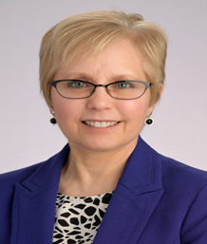

Cynthia Alvey is currently completing her term as the Ohio Valley District Director for KONL. During her term, she facilitated resumption of in-person district meetings and served on the Program Planning Committee. Cynthia’s past KONL Board/leadership roles include Scholarship Committee Chair and completion of two terms as Treasurer. She expresses sincere gratitude for the leadership opportunities KONL membership has provided, recognizing the organization as a rich resource for professional networking as well as a great place to develop personal connections and friendships.

