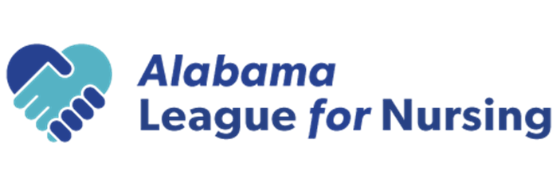

Certified Nurse Educator (CNE) Exam Scholarship

Scholarship:
The scholarship is a one-time amount of the cost of the CNE examination

Criteria:
The minimum qualifications for the award are as follows:

The applicants must:

- have a current membership in the Alabama League for Nursing (ALN)
- have an active, unrestricted Alabama nursing license
- have successfully passed the NLN Certified Nurse Educator Examination within the past 12 months.
- attend annual conference to receive the award

The recipient is required to submit the application along with the copy of the CNE certificate.
Scholarships will be awarded during the Alabama League for Nursing Annual Conference. Names will be drawn from qualified attendees using a random number generator and presented at the conference. Late entries will not be accepted.

Return all required documentation before January 9, 2026, via email to:

Donna Guerra, EdD, RN, CNE
dsg0011@uah.edu
Subject Line: ALN CNE scholarship

The scholarship will be awarded to a qualified applicant regardless of age, sex, race, religion, or political affiliation

Certified Nurse Educator (CNE) Exam Scholarship Application

PLEASE PRINT OR TYPE

Name: _______________________________________________________________________
(First) (Last)

Address: _____________________________________________________________________
(Street) (City) (State) (Zip)

Telephone: Home/Cell (____) ________________ Email: _______________________

Are you a current member of the Alabama League for Nursing? Yes ________ No __________

Do you hold a current Alabama nursing license? Yes _______ No _______

Alabama RN License Number: _________________

Current employment: ____________________________________________________________

Please attach the following documents:
1) Application
2) Copy of CNE certificate

Date: _______________________ Applicant’s Signature: _____________________________

