VT/NH APAN 2026
Spring Conference
Saturday April 11, 2026 Davis Auditorium
University of Vermont Medical Center
To receive contact hours, you must be present on the date and time indicated for the entire conference and complete the required posttest and evaluation form. No partial credit is awarded.
No partial credit is awarded. This event will not be recorded.

Picture Consent Statement: Attendance at VT/NH APAN programs and events constitutes consent to be photographed for use in print and/or electronic publicity for VT/NH APAN

Planning Committee

Sandie Watts and Denise Martel
For additional information regarding this conference please contact:

Kimberly Mihelich at mihelich@vtnhapan.org

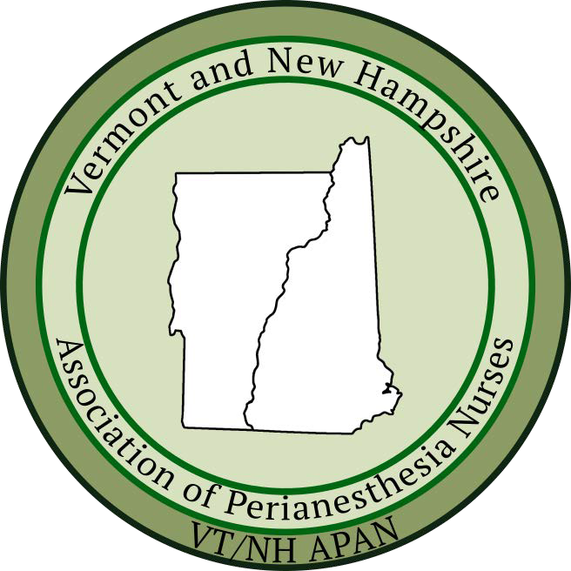

Registration Fees
Region 4 APAN Member- $65.00
Non-member- $85.00
Prelicensed Student- $20.00

Online registration only available at:
https://vtnhapan.nursingnetwork.com/

VT/NH APAN 2026
Spring Conference

Saturday, April 11, 2026
Registration begins at 7:45 AM
In person attendance
Davis Auditorium
UVM Medical Center
111 Colchester Ave
Burlington, VT 05401



Learning Outcome:
To enable the nurse to increase knowledge on peri anesthesia regional blocks, safety and emergency recognition, care of neurodiverse children utilizing optimal communication techniques in the perianesthesia environment, culturally competent perianesthesia care, sensitivity to LGBTQ+ diverse identities and
patient populations, and care of BPH patients.

Target Audience:
All perianesthesia nurses and nurses interested in
the specialty of perianesthesia nursing.

Special Thanks:
The VT/NH Board would like to thank Mary Gagne for assisting us with obtaining CEUs. We would like to thank our secretary, Dorothy Flowers, RN for her tireless efforts helping to organize and plan our conference and help recruit speakers. This is a large group effort and we could not do this without dedicated volunteers.


 | Paige Georgiadis, MD | Regional Anesthesia Review: Common blocks, New Blocks, Complications & Emergencies
Conference Schedule
7:45 | Registration | Please visit registration table to sign in
8:00 | Paige Georgiadis, MD | Regional Anesthesia Review: Common blocks, New Blocks, Complications & Emergencies
9:00 | Jennifer Eddy & Sarah Taylor MS, CCLS, | Better Care Through Communication
Break 10:00-10:20
10:20-12:00 | Geera Demers, Director of Culture & Experience, CPHQ & Taylor Small, BS | Identities, Bodies, and Relationships
Lunch 12:00-12:45 | Hot lunch catered by Kountry Kart
12:45-2:15 | Kimberly Mihelich MSN Ed., RN, FNHHC, CPAN | Culturally Competent Perianesthesia Care; DEI in Practice
2:15-3:15 | Amy Dooley MS, RN, CPAN, CAPA, FASPAN | Optimizing Same Day Discharge After Surgery for BPH: Criteria, Safety & Outcomes
3:15-3:30 | Evaluation and Closing and ASPAN update

VT/NH 2026 Spring Conference Disclosure
In support of improving patient care, The Robert Larner College of Medicine at The University of Vermont is jointly accredited by the Accreditation Council for Continuing Medical Education (ACCME), the Accreditation Council for Pharmacy Education (ACPE), and the American Nurses Credentialing Center (ANCC), to provide continuing education for the healthcare team.

This program has been reviewed and is acceptable for up to 6.0 Nursing Contact Hours.

Meeting Disclaimer: Regarding written materials and information received, written or otherwise, during this Conference, the scientific views, statements, and recommendations expressed during this activity represent those of the authors and speakers and do not necessarily represent the views of the University of Vermont.

Relevant Financial Relationships*
All those with control of content (speakers, planners, moderators, reviewers, staff) who have relevant financial relationships with “ineligible companies” are listed below (name of company only/no logos, trade names, or product group messages). An “ineligible company” is defined as those whose primary business is producing, marketing, selling, reselling or distributing healthcare products used by or on patients.

No speakers, planners or CMIE reviewers have any relevant financial relationships with ineligible companies.

Support received from Ineligible Companies:

We have not received any support

