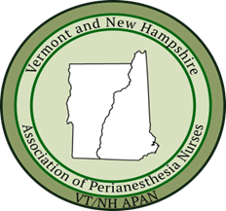

Spring 2026 VT/NH APAN Conference Schedule

7:45 | Registration | Please visit registration table to sign in
8:00 | Paige Georgiadis, MD | Regional Anesthesia Review: Common blocks, New Blocks, Complications & Emergencies
9:00 | Jennifer Eddy & Sarah Taylor MS, CCLS, | Better Care Through Communication
Break 10:00-10:20
10:20-12:00 | Geera Demers, Director of Culture & Experience, CPHQ & Taylor Small, BS | Identities, Bodies, and Relationships
Lunch 12:00-12:45 | Hot lunch catered by Kountry Kart
12:45-2:15 | Kimberly Mihelich MSN Ed., RN, FNHHC, CPAN | Culturally Competent Peri anesthesia Care; DEI in Practice
2:15-3:15 | Amy Dooley MS, RN, CPAN, CAPA, FASPAN | Optimizing Same Day Discharge After Surgery for BPH: Criteria, Safety & Outcomes
3:15-3:30 | Evaluation and Closing and ASPAN update | Sandie Watts

