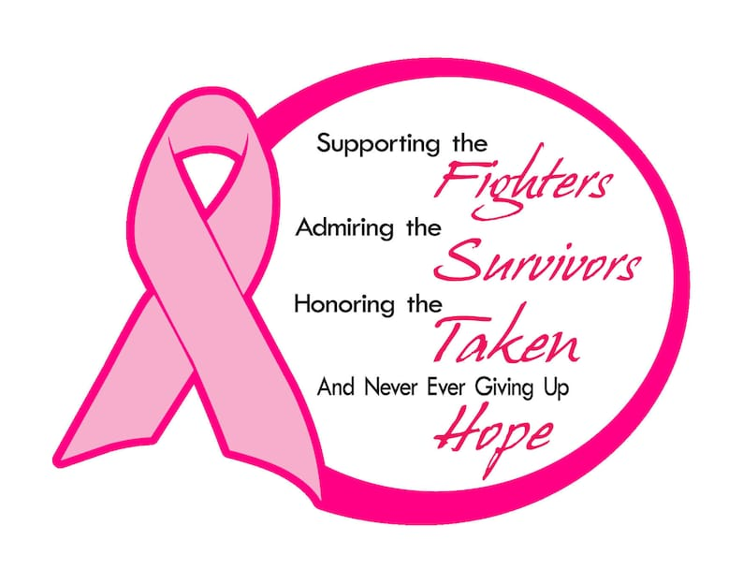

4th Annual West Penn OR
Breast Cancer Awareness Support The Girls Collection
In honor of Breast Cancer Awareness Month, West Penn’s OR will be collecting products to support girls and women of all ages & sizes.
Items that are needed are:
New & gently used bra’s that have the size clearly marked.
New & still in the package underwear.
All types of feminine hygiene products.
Donated products will be taken to Levana Bratique in Wexford. Levana is Latin meaning ‘to lift’. For years Levana has worked with I Support The Girls (ISTG), a national organization based out of D.C. ISTG creates various kits including A.S.H. (Aid, Safety, Hygiene), D.A.S.H. (for survivors of domestic violence), and FLASH for those experiencing menopause. These much-needed kits are distributed to: breast cancer survivors, low income school districts & youth programs, Native Americans, immigrants/refugees/migrant workers, Veterans, national & international disaster relief.
https://isupportthegirls.org/affiliates/pittsburgh/
Thank you!

