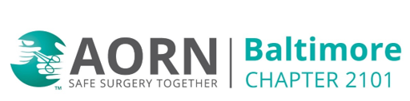

AORN Chapter Meeting
November 11, 2025 @6pm
Harnessing the Promise of Nursing
Short film Facilitation by Diane Couchman
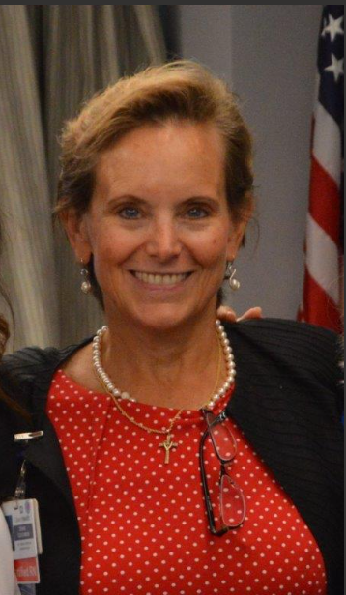
Hosted by: Baltimore Washington Medical Center
301 Hospital Drive, Glen Burnie, 21061
Conference Room 4 West

Zoom Meeting:
https://us02web.zoom.us/j/8253651972?pwd=OVZ3SkVmdUcrZ1NEczBrMVNYOEhuUT09
Meeting ID: 825 365 1972
Passcode: 0mbpVY
One tap mobile
+13017158592,,8253651972#,,,,*676091# US (Washington DC)
+13126266799,,8253651972#,,,,*676091# US (Chicago)

Dial by your location
+1 301 715 8592 US (Washington DC)
+1 312 626 6799 US (Chicago)
Meeting ID: 825 365 1972
Passcode: 676091
Find your local number: https://us02web.zoom.us/u/kbIEfjZcnO

CE approved

