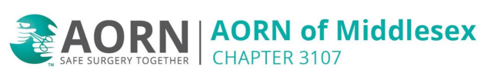

HAPPY HOUR
Let’s celebrate!
Food, drinks, laughter and good company!

Tuesday November 26, 2025 at 6pm

22 West Tap and Grill
1601 US 22, Bridgewater NJ


Sponsored by
Ian Sims (ForTec Laser)
Matt Kibler (Phillips)

