Central San Joaquin Valley Chapter of
AORN Presents

“Biosurgery and Wound Closure”

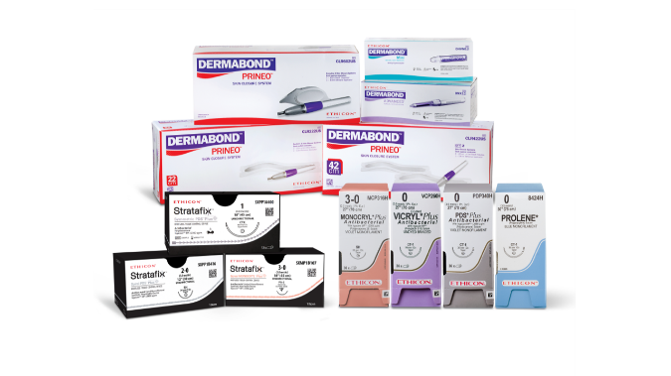
by Ethicon

Monday,
November 10, 2025 @ 6:00 P.M.

Ethicon
Will be hosting the CE dinner meeting at

Manhattan Steakhouse
1731 W. Bullard Ave, Fresno

Seats are limited to 25 attendees therefore, RSVP is REQUIRED!
Seating is limited

Send e-mail to kscaffidi@valleychildrens.org
Please include your name and facility

