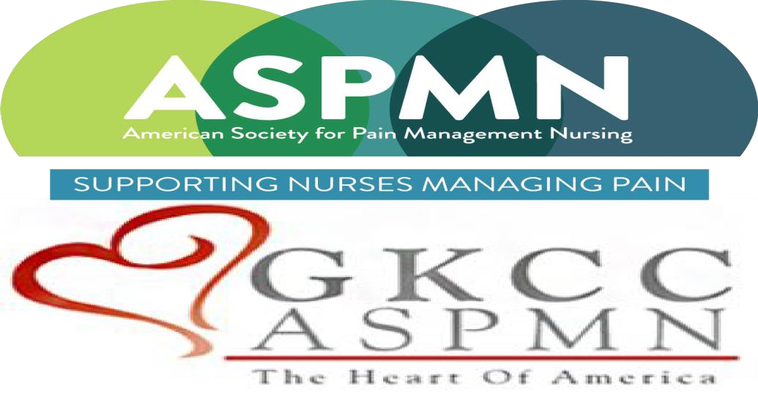  “A Role for Suzetrigine in the Management of Moderate to Severe Acute Pain”  A virtual presentation  by  Samuel D. Dolzani, PhD  Objectives:  - Demonstrate how one company’s strategies can be applied to improve acute pain management practices.  - Examine the role of voltage-gated sodium channels (NaVs) in pain pathophysiology.  - Apply knowledge of clinical trial methodology to interpret findings on the safety and efficacy of suzetrigine in acute moderate-to-severe pain management. | November 20, 2025  6:00-7:30 PM CST  Sponsored by Vertex Pharmaceuticals  This virtual event is free but registration is required @  https://gkccaspmn.nursingnetwork.com  Once you register on our website you will be sent a link for the zoom meeting.  The Greater Kansas City Chapter of the American Society for Pain Management Nursing is approved as a provider of continuing nursing education by the Kansas State Board of Nursing. This course offering is approved for 1.3 contact hours applicable for RN, LPN, or LMHT relicensure and 1.3 pharmaceutical CNE. Kansas State Board of Nursing Provider Number:  LT0279-0412GKCC-605.  Sam Dolzani, PhD is a medical science liaison on Vertex Pharmaceuticals’ pain team. Sam has over 15 years of experience across academic and industry settings. His professional experience includes National Institutes of Health-sponsored neuroscience research and roles within the commercial or medical affairs divisions of Abbott, Johnson and Johnson, Biohaven, Pfizer, and Vertex Pharmaceuticals. He earned his PhD and Master’s in Neuroscience from the University of Colorado, where his research focused on the neural circuitry underlying stress-related psychiatric disorders (i.e., depression, anxiety, and PTSD), neuroinflammation, and pain. Sam has coauthored 9 peer-reviewed neuroscience publications.

