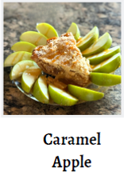

11/7
Order by Nov 7th
Online orders, Venmo only
Please indicate your order when sending Venmo. Include name and a phone number or send an email to Kris Scaffidi at kscaffidi@valleychildrens.org. Pick up is Nov 17th from 5–6 pm at 850 Palo Alto Ave, Clovis 93612. Local delivery by arrangement only.
These pies are amazing. You don’t want to miss out for the holidays ❤

