GATEWAY INS CHAPTER’S
LAST “HURRAH”
WHEN: Tuesday November 11th at 5:00 PM to 9:00 PM
WHERE: Bartolino’s Osteria 2103 Sulphur (Hampton/44)

AGENDA:
5:00 to 7:00 PM Visit Exhibitors
7:00 to 9:00PM Group Discussion

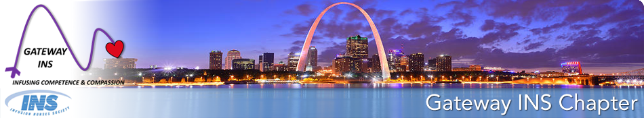

Please join us for our last meeting as a Gateway INS Chapter. National INS had decided to sunset the local chapter program and has asked all local chapters to be dissolved by December 31st, 2025. We will share the discussions that have taken place between local chapter boards; as well as those with the National INS CEO.

Industry representatives will be present with their products and available for you to consult with.

All clinicians, educators, managers, members, non-members, students, etc. are welcome and encouraged to attend. Please share this flyer with your peers, your customers and anyone you think this opportunity could benefit; rather themselves or their patients.

Look forward to seeing each and every one of you !! Best, Dana

RSVP: Gateway INS Website https://gatewayins.nursingnetwork.com/
or to Dana Runde at: darunde8@gmail.com text or call: 314-283-1204

