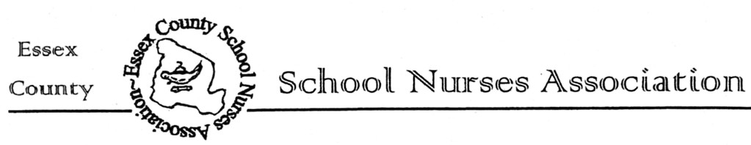
Essex County School Nurses Association
Invites You to an Educational Program

Facilitated by:
Michael Riley, EMT

Presentation Title:
"From Collapse to Care: Managing Cardiac Arrest in the School Setting"

WHEN: Wednesday, October 29, 2025 from 4:00-5:30 p.m.

WHERE: West Orange Public Library

10 Rooney Circle

THIS PROGRAM REQUIRES REGISTRATION

To register, copy and paste this link into your browser:

https://ecsna.nursingnetwork.com/nursing-events/148749-from-collapse-to-

care-managing-cardiac-arrest-in-the-school-setting#!registration

**1.5 Professional Development Hours will be offered for this program to paid ECSNA

members.

* Please see our ECSNA website at https://ecsna.nursingnetwork.com/ contact us at: https://ecsna.nursingnetwork.com/contact for any questions.

**To join ECSNA, please bring a check made payable to ECSNA for $30 for actively
practicing school nurses or $22.50 for an associate membership (ie. retired school nurses,
school nursing students, RNs interested in school nursing)

