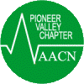

Pioneer Valley Chapter of AACN presents
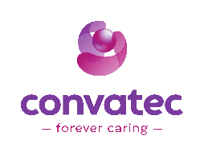

Imposter Pressure Injuries and Wound Hygiene
Speakers: Wendy Warnick BS, RN, CWCN, WCC, ONS & Kim Sisson MSN, RN, CCRN, CPXP
Wednesday October 22, 2025
Delaney House Holyoke, MA Registration 5:30-6 PM with dinner/lecture to follow

* Reserve your spot early*
PVC Chapter Members, FREE RSVP by 10/17/2025 Friday Cathie Manning cathietom@aol.com
Non-members $20.00 Donations for Community Outreach- Feminine Hygiene products

