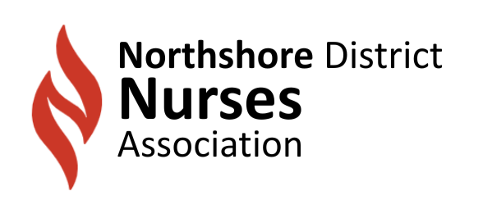 | NEWSLETTER
Summer Issue SHARE WITH OTHERS 3rd Quarter 2025
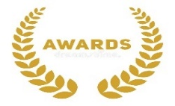 | NDNA 2025 NURSING EXCELLENCE AWARDS  We are expanding to twenty-five recipients now that we have added Tangipahoa Paish. In addition, we are moving to a Gala format with a sit-down dinner presentation of awards. Voting concluded on Sept. 1, 2025. Seven facilities are represented with eighty-seven applications received along with four Nifty-Fifty nominees. The Award Dinner will be held on 11/4/2025 6-9pm @ Benedicts in Covington. Tickets can be purchased on the NDNA website. Member discounted. northshoredna.nursingnetwork.com.
 | NDNA GALA SPONSORSHIP  To support this event and defray costs, NDNA solicited sponsorships. The levels range from $250 to $3,000 with progressive perks per level of donation. Sponsors include:  - Indicator Sciences, St. Tammany Health System  - Ochsner Health, AVALA  - LOPA, SLU  - SMH/Ochsner Open until October 1st.
 | CONGRATULATIONS TO NORTHSHORE AWARD WINNERS  Great 100:  Janice Augustine, Elizabeth “Tren” Garbo  Nightingale:  Facilities: Our Lady of Angels, Bogalusa, Northshore Technical Community College  SLU Undergraduate Program
 | Remaining 2025 Events  11/18 -5:30PM-General Meeting/CE PROGRAM: “Enhancing Care: Impact of Malnutrition Screening Tool and Referral Algorithm in Adult Oncology Patients, Presented By: Debbie Carambat, MSN, RN Sponsor: Northshore Technical College STAC  12/9-5:30P BOD Meeting/Christmas Social – food, fun, fellowship. Bring a dirty Santa gift < $20. TBA  Registration required: kaysabadie@gmail.com
 | COMMUNITY EVENTS  We offer participation in these community events in an effort to promote nursing visibility in charity causes that promote health and wellness.  9/20- Walk Together! Alzheimer’s Walk, 9am at Lakeview Hospital  https://act.alz.org/site/TR?team_id=940225&pg=team&fr_id=18636  10/11-Louisiana Walks for Parkinson’s Presented by Supernus: Event Information - Parkinson's Foundation
 | The 2026 NDNA Calendar  The calendar of events for 2026 is currently being developed. We are seeking recommendations for CNE Topics/Speakers and charitable events to support. Contact Kay Sabadie, NDNA Program Coordinator kaysabadie@gmail.com
 | FOLLOW US: Keep current on social media:  Website - https://northshoredna.nursingnetwork.com Facebook – northshore district nurses association  Linkedin: - Northshore District Nurses Association-NDNA  LSNA – www.lsna.org

