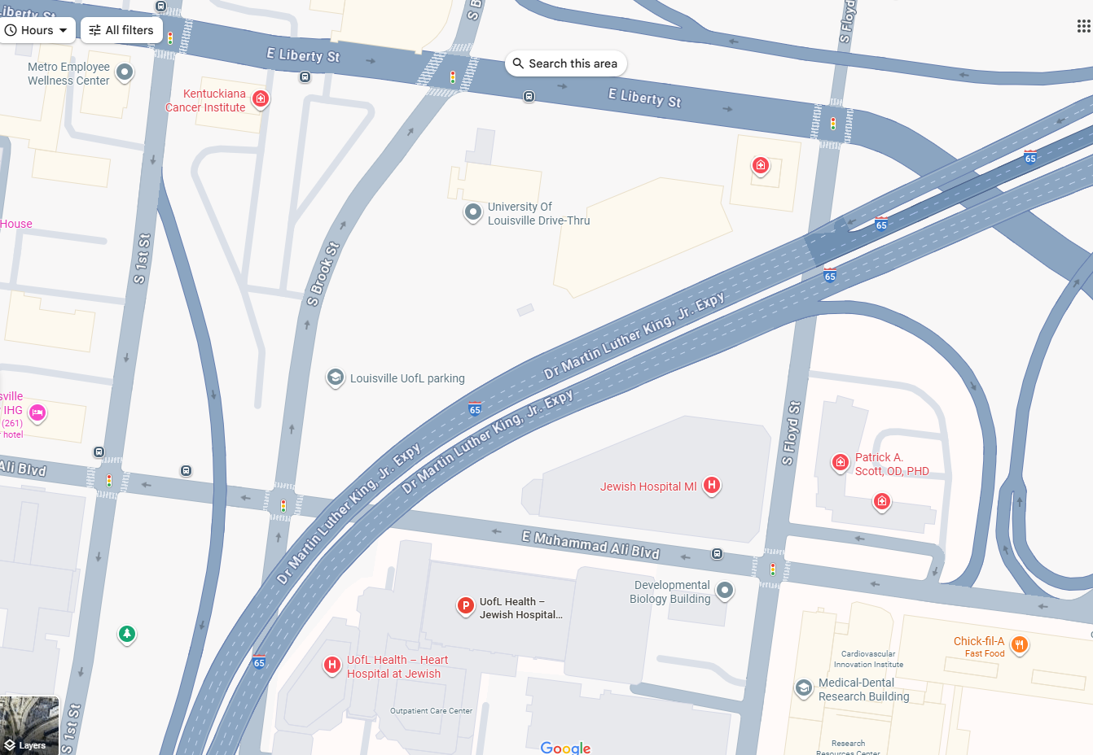
Parking Information:
Guests may park in the Skycare Lot in between Muhammad Ali Blvd. & Liberty St. located at 499 S. Brook St. Louisville, KY 40202. Please note that any space that is marked "reserved" is being utilized by our valet service. Additional parking location is the Jewish Hospital parking garage - this is a paid parking.

