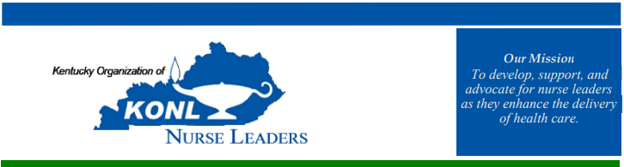
HOTEL OPTIONS:
- AC Hotel – Nulu
  - 727 East Market St. Louisville, KY 40202
  - 10 Rooms blocked – can add more if there’s more available before due date.
  - Rate: $259+tax
  - Cut-off date: October 2, 2025
  - No financial obligations if rooms are not booked by due date.
  - Link:
    - Book your group rate for KY Nurse Leader Conference
- Hampton Inn & Suites – Louisville East
  - 400 Bullitt Lane Louisville, KY 40222
  - 20 Rooms blocked:
    - Double Queen: $169+tax
    - Single King w/ couch: $169+tax
  - Cut-off date: September 25, 2025
  - No financial obligations if rooms are not booked by due date.
  - Link: KONL Group
- Radison Hotel – Louisville North
  - 505 Marriott Drive Clarksville, IN 47129
  - 20 Rooms blocked:
    - Two Double Beds: $70+tax
    - King: $70+tax
  - Cut-off date: October 8, 2025
  - No financial obligations if rooms are not booked by due date.
  - Link: Rates & Available Rooms - Radisson Hotel Louisville North
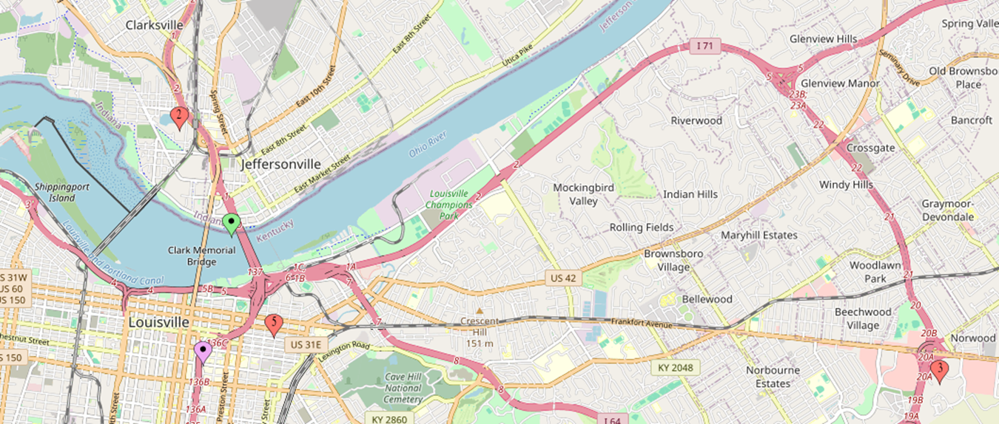
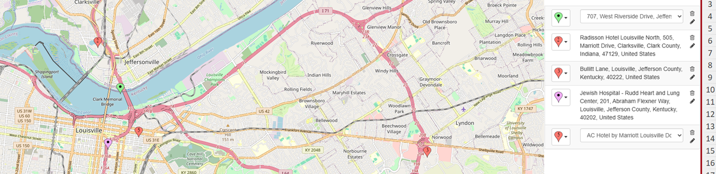

Purple - Rudd Heart Hospital
Green – Upland Brewing Co.
#1 - Radisson Hotel
#2 - Hampton Inn and Suites
#3 - AC Hotel

