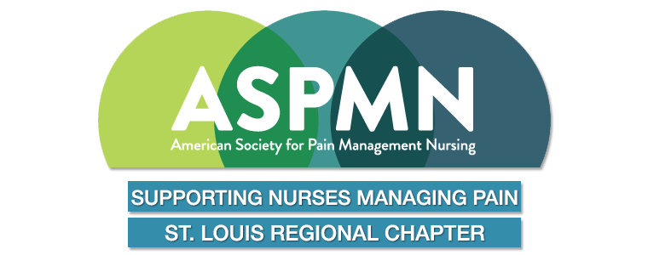
“Commit yourself to lifelong learning. The most valuable asset you’ll ever have is your mind and what you put into it.” Albert Einstein

Chapter Newsletter

Volume 25 Issue 3 2025

1 Word from the President

2 CNE opportunities / National Conference Info

3 Research Grant / Pain Nurse of the Year / Meeting Dates 2025 / Board Members
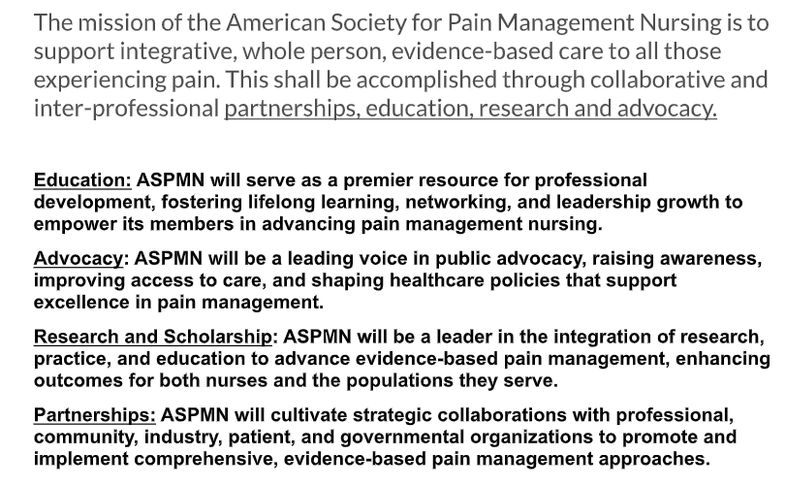


Word from the President…
As we welcome Fall, we have many opportunities for continuing education both in person meetings and virtual sessions. Your local chapter is interested in partnering with other organizations and we plan to offer a session in November with a Holistic nurse. More information will be available very soon but Save the Date of November 5 on your evening calendar.
Two of our chapter board members are traveling to attend the National Conference this year. We are excited and plan to bring information to share. Lifelong learning and sharing knowledge is one of our chapter goals. Our National President for ASPMN June Oliver says “stay M.I.A. Mission-driven, Imagination friendly, Action-oriented.”

Yours sincerely,
Jean Brontoli BSN, RN



St. Louis Regional Chapter ASPMN Coordinating FREE CNE 1.7 Pharmacology
September 16, 2025 via Zoom

What is New in Pain Pharmacology?
Speaker: Linda Vanni
MSN, PMGT-BC, ACNS-BC, NP, AP-PMGT
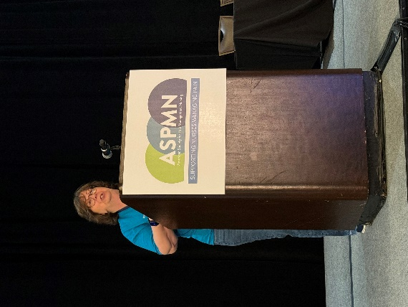
Join us for a highly informative Webinar to explore the most recent pharmacology updates as it relates to pain management. Linda is well known for her specialty in pain management as a clinician, consultant author and lecturer nationwide. We are grateful for her to share her pain updates. Our speaker has declared no conflict of interest.
FREE Virtual CNE Education
Zoom Meeting Link


National Conference and Continuing Education Available on ASPMN Website
https://aspmn.org/
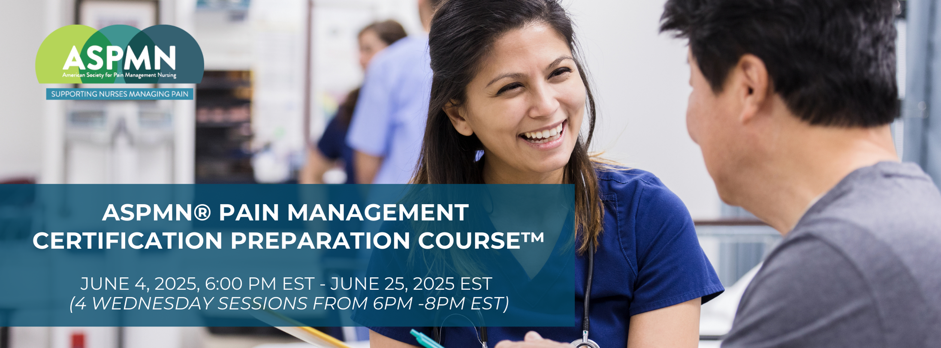

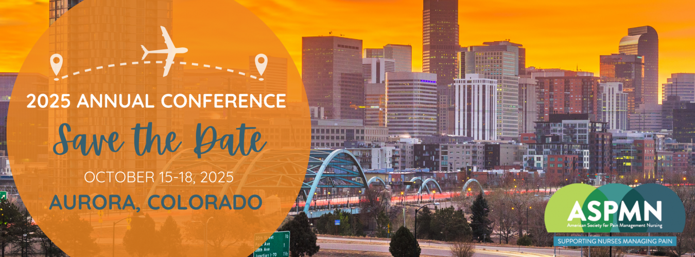

St. Louis ASPMN Research Grant – available on website
Pain Nurse of the Year Award- available on website

ASPMN MANTRA:
Every nurse is a pain care nurse. It’s imperative to stay up to date on cutting edge pain management techniques, therapies, and industry advancements.

2025 Business Virtual Meeting Dates:
Mark your calendars & we’ll post More Information on the Website as available:
November 5, 2025 In Person Meet & Mingle and CNE
Link available by email will be published when available

CHAPTER NEWS:
REMEMBER THAT STL CHAPTER MEMBERSHIP IS FREE TO EVERYONE!! HOWEVER, YOU NEED TO RENEW YOUR CHAPTER MEMBERSHIP ONLINE AND YOU NEED TO BE A MEMBER OF THE NATIONAL ORGANIZATION TO BE ELIGIBLE FOR THIS ONE YEAR FREE STL MEMBERSHIP. PLEASE ENCOURAGE ALL NURSES TO JOIN!!

St. Louis Regional ASPMN Board Members 2025:
President – Jean Brontoli ( jbrontoli@gmail.com)
Past President –
President Elect – Open Position
Secretary currently rotating - Open Position
Treasurer - Linda Feinberg (dunajciklm@aol.com)
Program Chair & Past President - Gail Hurt
(gail1202hurt@gmail.com)
Nominations - Ann Bearden (anncolbear@aol.com)

