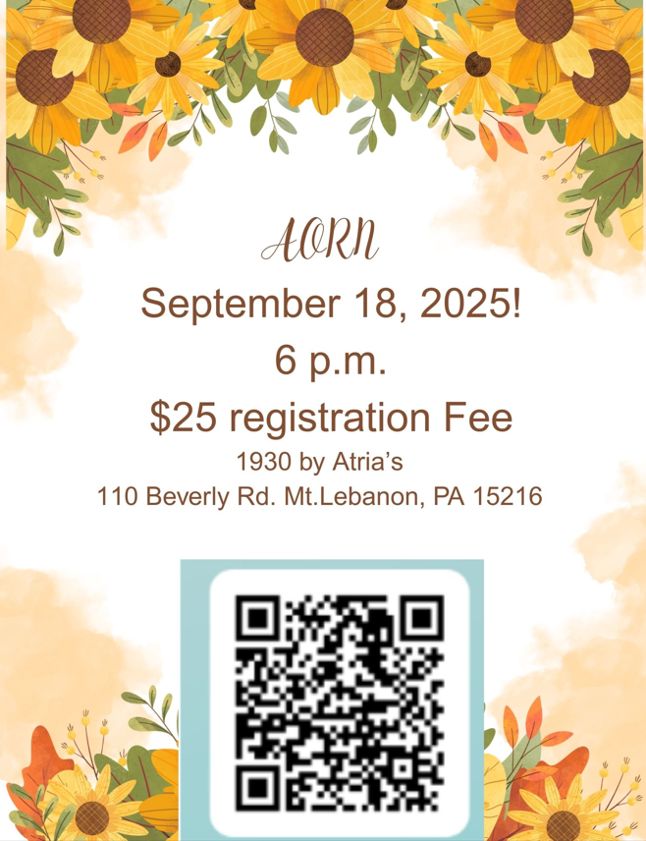

Bring donations for the Fall Back to School Food Drive!

Sponsorship by Solventum-Normothermia.