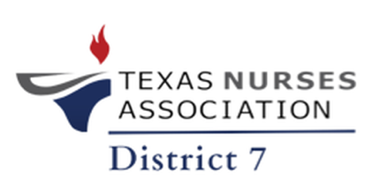
Texas Nurses Association: District 7
Monday, August 4, 2025, 6 PM
Bar 1859
21 North Main Street
Salado, TX 76571
- Call to Order : 1800
- Welcome/opening remarks
- Roll Call (Establish Quorum)
  - 17 total in attendance
  - 1st time attendee Tracy – Welcome Tracy!
- Approval of the Minutes: July 7, 2025 Motioned by Tina Morris, 2nd by Maddie Papica; Approved
- Correspondence
- State & District Reports
  - District Report
    - Membership Report: Reported continued upward trend, with continued focus on gaining new membership and engagement
    - Treasurer Report
      - Balance $13,797.74
        - Spent $131.00 @ Sam’s Club, $16 for snacks, $60 @ Staples for supplies, $100 for Sponsor
  - State Report
    - Announcement of State Committee Appointments: Ebony Gebrehawariat (Policy Committee), Marissa Hudler (Nurse Practice Committee), Marlene Porter (Policy Committee)
    - District Leader Orientation – August 15, 2025 at 10 AM
    - Nurse Talks – August 14, 2025, at 6 PM CST
- Committee Reports: Note all meetings are virtual/hybrid unless stated otherwise
  - Early Career Nurse Committee: Tuesday, August 12, 2025, 6:00pm
  - Programs/Events Committee: Monday, August 18, 2025, 6:00 pm This committee needs some help. Pam Sanford agrees to help
  - LVN Committee: Friday, August 22, 2025, 6:00 pm (Location TBD)
  - Scholarship Committee: Saturday August 30, 2025, 1:30 pm
  - Bylaw Committee: Monday, September 8, 2025, 6:00 pm
  - Awards & Recognition Committee: Wednesday, September 10, 2025, 6:00 pm
  - Great discussion on the importance of getting committee engagement and involvement to move the chapter forward. Ebony encouraged everyone to view Nursing Network for descriptions of the committees and get involved in these committee, further enhancing the work of this chapter.
- Business
  - Signature Event: symposium, fundraising gala, workshop – What will it be? What to do with the funds raised? Ideas tabled for next meeting
- Open Floor
- Announcements
  - Scrubs & Screenings: Everybody’s Work: Healing What Hurts Us All on August 23, 2025, at 1-4PM at UMHB Isabelle Rutherford Meyer NEC
  - Lunch N’ Learn: Wednesday, August 27, 2025, at 12 PM CST at Temple College
  - Common Ground: September 20, 2025, at 9 AM, On-the-Go Coffee Co.
- Adjournment – Lisa motioned, Marlene 2nd. Meeting adjourned @ 1845
  - Next Meeting: Monday, October 6, 2025, at Texas A&M University - Central Texas, Killeen, Texas, with the Tau Epsilon Chapter: Joint Legislative Update

