2103 AORN Chapter Meeting
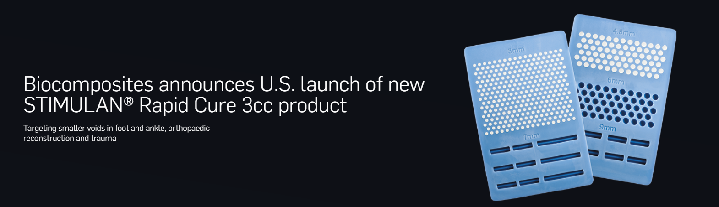
  - USA STIMULAN Presentation

September 8th, 2025 @ 630pm
Robinwood Professional Center, 11110 Medical Campus Drive, Hagerstown, MD. Suite 122B

