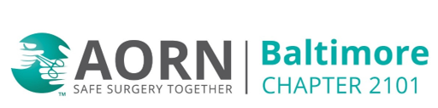

September 9, 2025 @6pm
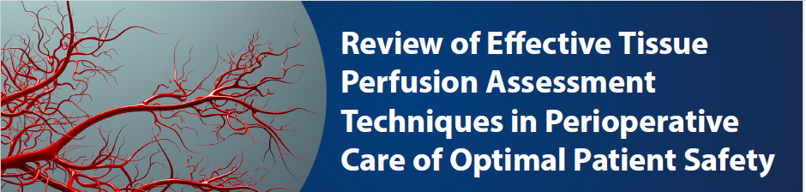

Speaker: Ann Kuebler

Zoom Meeting:

https://us02web.zoom.us/j/8253651972?pwd=OVZ3SkVmdUcrZ1NEczBrMVNYOEhuUT09
Meeting ID: 825 365 1972
Passcode: 0mbpVY
One tap mobile
+13017158592,,8253651972#,,,,*676091# US (Washington DC)
+13126266799,,8253651972#,,,,*676091# US (Chicago)

Dial by your location
+1 301 715 8592 US (Washington DC)
+1 312 626 6799 US (Chicago)
Meeting ID: 825 365 1972
Passcode: 676091
Find your local number: https://us02web.zoom.us/u/kbIEfjZcnO

2.0 Contact Hours California Board of Registered Nursing

