|  |  |  |  |  |
| --- | --- | --- | --- | --- |
| **AORN RNSA** | |  | **August 2025** | |
|  | **Retired Nurses Special Assembly Newsletter**  **By and for AORN nurses** | | |  |
|  | | | | |

Please note our group name. We are made up of retired nurses but also include those of you that are taking a break from work for various reasons. As older retired nurses, we offer ourselves as educators, sharers of our years of knowledge and experience. All we need is for someone to ASK, and you will be surprised at what you learn.



Summer months (Jul-Aug) no meetings

Reconvene in **September.**

September 25, 2025: 8 PM Eastern, 7 PM Central, 6 PM Mountain, 5 PM Pacific.

RNSA scheduled Zoom meeting, link will be posted and should turn up in your email. If not, let us know.

<https://aornretired.nursingnetwork.com/>

This is the link to our new homepage. If you have not signed into the AORN main page, you will probably need to do that to access the nursing network site, which will require another sign-in. Once you have found a group, you have dropdowns on the left that you can explore. Announcements for upcoming meetings or events may be on the front page for the group. Check out the space and explore. Let us know if you have any questions. We’ll help!!

*The Retired Nurses Specialty Assembly is for perioperative nurses who are retired, in transition toward retirement in their careers, or interested in tapping into the expertise of perioperative nurses with a vast array of experience in a variety of specialties.*

·       *Provide a forum for networking for retired nurses and other members interested in learning about the Retired Nurses Specialty Assembly.*

·       *Increase communication and collaboration among nurses who have similar work functions.*

·       *Serve as a resource for AORN in all areas of perioperative nursing.*

·       *Serve as a resource for the membership of AORN on matters concerning retirement.*

If you are interested in joining us, or to come and visit, we can be found by going to:

<https://aornretired.nursingnetwork.com>

*Member Spotlight*

*David Reinhart*

*Board Liaison*

From our AORN site: Our President-Elect is David Reinhart, DNP, MBA, CNOR, FAAN!”

Please join in welcoming him as our new board liaison. The spelling of his last name is tricky: R E I N H A R T

AND his email is [davidreinhartrn@gmail.com](mailto:davidreinhartrn@gmail.com)

Be sure to add the RN to the address and no spaces between his first/last name. If you use a different email with his name, it won’t go to our AORN special board liaison!!!

More to come on special homilies for David, but for now this is a repeat of his awesome credentials.

David Reinhart, DNP, MBA, RN, CNOR, FAAN, is the Director of Nursing Education, Emory Healthcare, for Procedural Residency Programs. He earned his DNP from Georgia College and State University, Milledgeville, Georgia; his MSN from the University of St. Francis, Joliet, Illinois; and his MBA from the University of Dallas, Dallas, Texas.

Reinhart has been a perioperative nurse for 38 years and a life member of AORN. His experience progression started with his role as a nurses’ aide, surgical tech, staff nurse, supervisor of nursing, manager of nursing, director of nursing, and then finally his present position of director of education for Procedural Residency Programs. He is a member of ANA, GNA, and Sigma Theta Tau. He is currently serving on the national AORN Board of Directors as PE and participates in the AORN Executive Roundtable meetings. Dr. Reinhart was inducted as a fellow into the American Academy of Nursing in 2024.

He is our board liaison and, when available, attends our monthly meetings. If there is a conflict, he sends updates to our chair.

_____________________________________________________________________

For those that like to read or listen to audiobooks:

### **Libby App: Free ebooks & audiobooks from your library**

OverDrive https://www.overdrive.com

You can **Access thousands of free ebooks & audiobooks online** with Libby, the library reading app by OverDrive. Enjoy free reading & listening on any device.

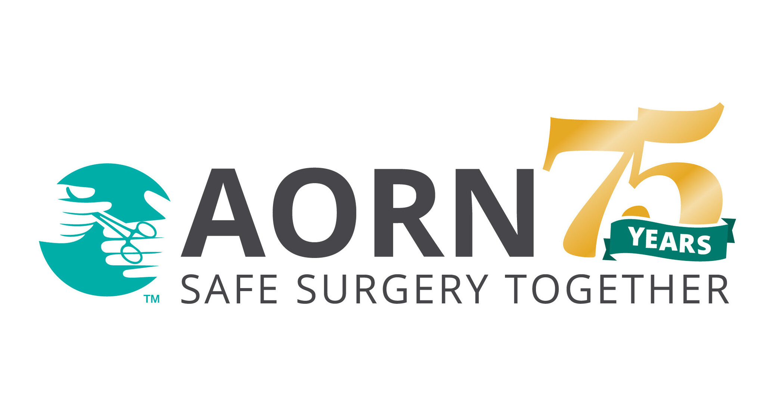

**AORN New Orleans Chapter 1902**

**will be celebrating their Chapter's 75th Anniversary on October 15, 2025. Thank you, Nathalie**

**Food FOOOD FOOOD YUMMY FOOD**



Ingredients:  
  
Cake:  
1 1/2 cups all-purpose flour  
1 teaspoon baking powder  
1/2 teaspoon baking soda  
1/2 teaspoon salt  
3 large eggs  
1 cup granulated sugar  
1 cup sour cream  
1/2 cup vegetable oil  
2 tablespoons lemon zest  
1/4 cup fresh lemon juice  
1 teaspoon vanilla extract  
1/2 teaspoon lemon extract (optional, for extra flavor)

Glaze:  
1 cup powdered sugar  
2 tablespoons fresh lemon juice  
1 tablespoon milk (optional, for thinning)  
  
Directions:  
  
**Preheat oven:** Set oven to 350°F (175°C). Grease and flour a 9x5-inch loaf pan or line it with parchment paper. Bake for 50–55 minutes, or until a toothpick inserted into the center comes out clean.  
  
  
**Mix dry ingredients**: In a medium bowl, whisk together flour, baking powder, baking soda, and salt.  
  
**Prepare wet ingredients**: In a large bowl, whisk eggs, sugar, and sour cream until smooth. Gradually add oil, lemon zest, lemon juice, vanilla extract, and lemon extract. Stir until well combined.  
  
**Combine wet and dry**: Slowly add the dry ingredients to the wet mixture, stirring until no lumps remain.  
  
Bake: Pour the batter into the prepared loaf pan.   
Cool: Allow the loaf to cool in the pan for 10 minutes, then transfer it to a wire rack to cool completely.  
  
Prepare the glaze: Whisk powdered sugar, lemon juice, and milk (if needed) until smooth. Drizzle over the cooled loaf.  
  
Prep Time: 15 minutes | Cooking Time: 55 minutes | Total Time: 1 hour 10 minutes  
Kcal: 310 kcal | Servings: 8–10 slices  
  
Tips:  
Use fresh lemon juice and zest for the best flavor.  
Chill the loaf before glazing to prevent the glaze from soaking in too quickly.



**WHAT IS THIS? WILL BECOME A CONTINUED FEATURE, SO IF YOU HAVE A STRANGE SOMETHING THAT YOU WOULD LIKE TO SHARE, SEND TO ME (PAM) AND I’LL ADD.**

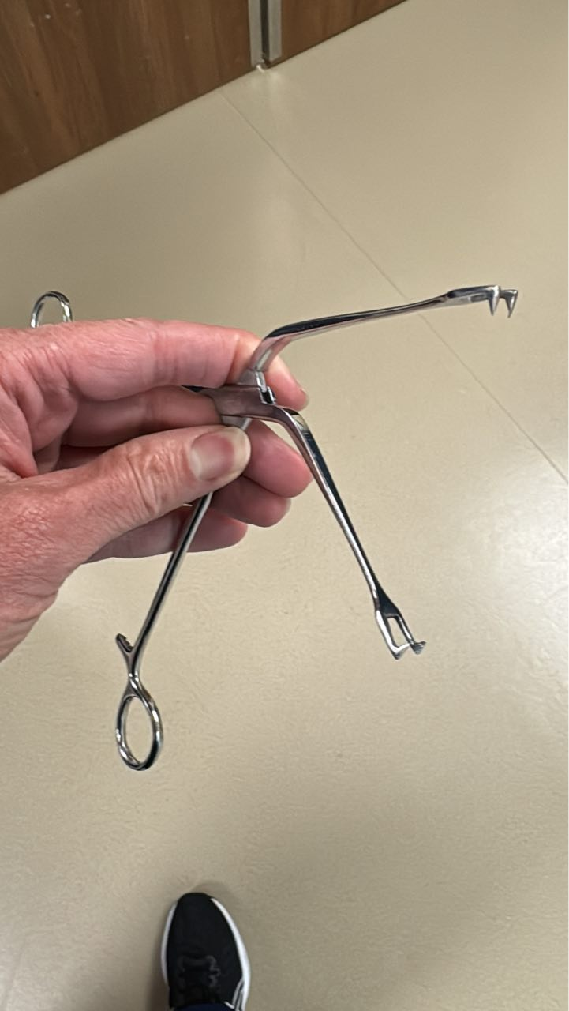

a) Schroeder (from Ohio)

b) Jacobson (from NYC)

c) Mueller (from Germany)

d) Alibaba (opensesime)

e) Mueller-Schroeder Curved

f) Schroeder-Mueller Double Tooth

g) some sort of tenaculum used somewhere that hurts if awake

**EDUCATIONAL EVENTS**

Melaine Burton [quientessential@comcast.net](mailto:quientessential@comcast.net)

Has given talks/presentations at various places in her hometown: Seattle, WA. She ‘works’ with the public health department/healthcare clinic. Recently she oversaw 4K patients on a weekend afternoon throughput to the quiet room with the intent of

monitoring patients’ blood pressure readings. Second readings indicated quiet rooms had a positive patient outcome of assisting a decrease in BPs.

She also encouraged nurses to ‘tell us what you would like to hear at next year’s expo. Tell us.

She presented Successful Aging Talks and had lots of contacts.

She expressed that the Expo 2025 Update Needs Assessment needs to be completed. It is never too early to begin this process.

**Last thoughts:**

Comments and/or RNSA Newsletter materials, suggestions, etc., are welcome and may be sent to:

Pamayla Darbyshire [usafrnped@yahoo.com](mailto:usafrnped@yahoo.com)

**Thank you to all contributors.**

**RNSA Council:**

Chair: Cheryl Sumner, RN, CNOR (e) (OH)

Past Chair: Cathy Ostroski, DNP, RN, CENP (NJ)

Chair-Elect: Cheryl Sumner, RN, CNOR (e) (OH)

RNSA Mentor: Joanne D. Oliver-Coleman, MBA-HM, BSN, RN, CNOR (e) (TX)

Board Liaison: David Reinhart, DNP, MBA, RN, CNOR, FAAN

Communications Chair: Patricia Moody, RN, CNOR (e) (IN)

Communications Chair-Elect: Patricia Moody, RN, CNOR (e) (IN)

Education Chair: Melanie Burton, BSN, RN, CNOR, MLSO (WA)

Education Chair-Elect: Melanie Burton, BSN, RN, CNOR, MLSO (WA)

Newsletter: Pamayla E. Darbyshire, DHA, MSN/CNS (UT)