AORN of GREATER CLEVELAND
LaVera Dinner Fundraiser
Monday October 20th, 2025

Please help support our nursing scholarships, outreach programs, and our chapter education.

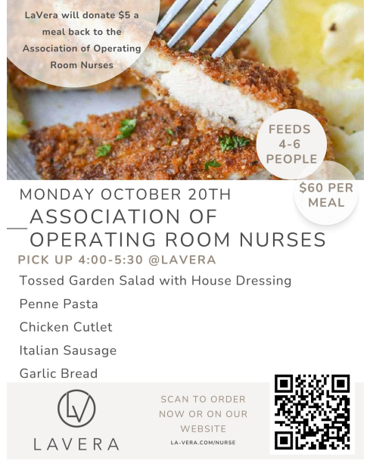
Please share this opportunity to enjoy a delicious meal without cooking with your family and friends.
https://www.la-vera.com/nurse
LaVera Party Center
32200 Chardon Road
Willoughby Hills, Ohio 44094
440-943-0087

