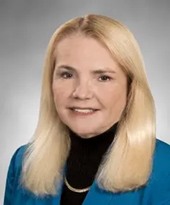***Join nurse leader colleagues from across the country for a highly interactive webinar presented by renowned nursing thought leader,***

***Rose O. Sherman, EdD, RN, NEA-BC, FAAN***

***Tuesday, November 19, 2025***

***1:00 – 3:30 pm EST***

**Dr. Rose O. Sherman**

***This engaging session aims to provide actionable tools and strategies for nurse leaders to help their work teams build intergenerational bridges, not walls,***

***as they work together to provide care.***

**COST: $99 – NYONL members $125 – non-members**

**$1,000 – 10 attendees from the same organization \***

**\* For group registrations, Contact us:** [**https://nyonl.nursingnetwork.com/contact**](https://nyonl.nursingnetwork.com/contact)

**Registration includes a PDF workbook tailored to the needs of nurse leaders in practice and academia.**



**To register click:** [**https://bit.ly/NYONLBuildingBridges**](https://bit.ly/NYONLBuildingBridges) **or**

This webinar is co-sponsored by NYONL and the

University of Rochester Center for Nursing Professional Development Provider Unit

The University of Rochester Center for Nursing Professional Development Provider Unit is accredited with distinction as a provider of nursing continuing professional development by the American Nurses Credentialling Center Commission on Accreditation.

2.5 CNE available.