**Important Information**

**Hotel Accommodations**

Hampton by Hilton

59 Portsmouth Ave, Exeter, NH

Dates: Thursday 9/25/25

Room Options: 1 king bed or 2 queen beds

Price $219.00

Check in 3:00pm, checkout 11:00am

Onsite parking, complimentary hot breakfast, wireless internet

***Reservations need to be made by 8/26/25.***

**Food Accommodations**

**\*Please email** [**neonesecretary@gmail.com**](mailto:neonesecretary@gmail.com) **as soon as possible with any dietary specifications\***

Breakfast/AM Snack provided by Exeter Hospital Cafeteria

* Coffee/Tea, orange juice, water, milk, soda, bagels, scones, muffins, breakfast sandwiches, fruit, yogurt, granola, condiments

Buffet Lunch provided by Liberty Lane Catering

* Chicken Piccata; NE Baked Haddock; Cavatappi with olives, tomatoes, EVOO
* Wild rice, roasted vegetables medley, garden salad
* Assorted breads, rolls, pastries, condiments
* Soda/water

Afternoon Snack provided by Exeter Hospital Cafeteria

* Assorted chips, cookies, cheese platter, water, soda, coffee/tea

**Driving Directions**

**From Boston:**

Take Route 95 North to New Hampshire. Take Exit 2 for Exeter, Manchester, Hampton Beach – Route 101 West. Take Route 101 West to Exit 11 marked Stratham-Newmarket. Turn left at the lights at the end of the off ramp onto Portsmouth Avenue/Rte. 108 South. At 2nd set of traffic lights turn left onto Alumni Drive to Exeter Hospital. Take a left at first stop sign to parking garage on your left.

**From Portland**:

Take Route 95 South to New Hampshire. Take Exit 2 for Exeter, Manchester, Hampton Beach – Route 101 West. Take Route 101 West to Exit 11 marked Stratham-Newmarket. Turn left at the lights at the end of the off ramp onto Portsmouth Avenue/Rte. 108 South. At 2nd set of traffic lights turn left onto Alumni Drive to Exeter Hospital. Take a left at first stop sign to parking garage on your left.

**From Manchester**:

Take Route 101 East toward Portsmouth. Take Exit 11 marked Stratham-Newmarket-Portsmouth. Turn right at the lights at the end of the off ramp onto Portsmouth Avenue/Rte. 108 South. At 2nd set of traffic lights turn left onto Alumni Drive to Exeter Hospital. Take a left at first stop sign to parking garage on your left.

**From Nashua Area**:

Take 111 to Exeter downtown area. At the bandstand turn right on Water Street. Go left at 1st set of traffic lights onto Portsmouth Avenue/Rte. 108 North. At 2nd set of traffic lights turn left onto Alumni Drive to Exeter Hospital. Take a left at first stop sign to parking garage on your left.

***\*See map below for navigating once on campus\****

***\*\*See map below for directions from hotel\*\****

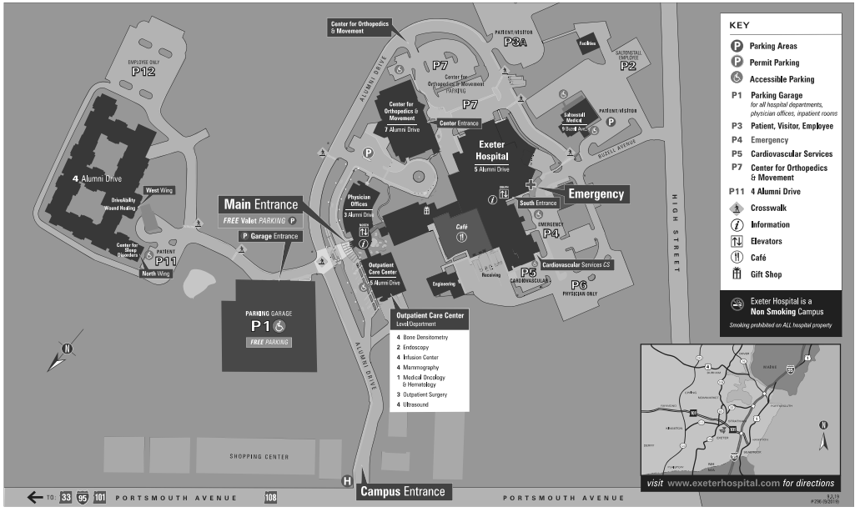

Hampton Hotel

Parking Directions

**Parking Garage**

FREE Parking

Please park on the second level and up, do not park on the first level as this is for patients.



Class, Lunch and Vendor Directions

*Star indicates entrance*

Vendors & Posters

Conference Sessions

**Parking Garage**