St. Louis ASPMN presents:

**“WHAT IS NEW IN PAIN PHARMACOLOGY!”**

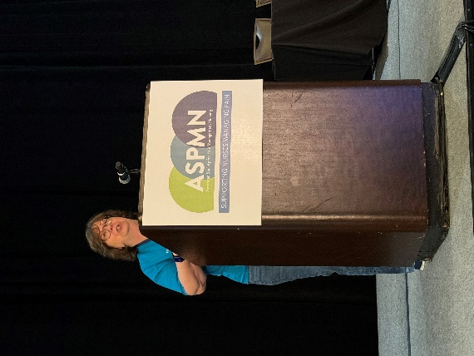

**DON’T MISS THIS OPPORTUNITY!!!**

**Presented by: Linda Vanni**

**MSN, PMGT-BC, ACNS-BC, NP, AP-PMGT**

When: **Tuesday, September 16, 2025**

Where: **FREE Webinar via Zoom with FREE CE’s**

Join us for a highly informative Webinar to explore the most recent pharmacology updates as it relates to pain management. Linda is well known for her specialty in pain management as a clinician, consultant and author. She has co-authored the ASPMN core curriculum chapter on Cancer Pain twice, lead author for the new 2025 core curriculum chapter on Pharmacology Pain Management Strategies, the ASPMN’s Director of Master Faculty for Advanced Pain Pharmacology and lecturer nationwide. We are grateful for her to share her pain updates. Our speaker has declared no conflict of interest.

**Register @** **[www.aspmnstlouisregional.nursingnetwork.com](http://www.aspmnstlouisregional.nursingnetwork.com) for FREE Webinar You will receive an email with the Zoom link to Join**

**You will not want to miss this session – FREE CNE**

Greater Kansas City Chapter of the American Society for Pain Management Nursing is approved as a provider of continuing nursing education by the Kansas State Board of Nursing. This course offering is approved for ___contact hours applicable for RN, LPN, LMHT re-licensure. Kansas State Board of Nursing provider numberLT0279-0412 GKCC592