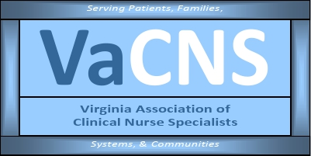

Our Mission:
Promote the role of the clinical nurse specialist as an advanced practice registered nurse in Virginia, and improve systems of care, prevent disease, and enhance health
and well-being through evidence-based care of populations.

MEMBERSHIP MEETING AGENDA
August 11, 2025
5:00 pm to 6:00 pm

Zoom Meeting:
https://us02web.zoom.us/j/611829893?pwd=Tkl1aWJOY0JhelVkMUlUaFpkK0MrZz09

Phone number 1-929-205-6099; Meeting ID: 611 829 893 Passcode: 329587

Discussion Items | Facilitator
Welcome & Announcements  - Introductions  - Member achievements  - Committee chair openings  - Nurse staffing in LTC, etc. letter | Jen/Members
Minutes
• Approval of minutes
Reports  • Treasurer  • Social Media  • Standing Committees  - Finance  - Program Planning  - Growth & Succession  - Legislative/Regulatory  - Open discussion | Holly Tenaglia  Amy Lucas  Cathy Smith  Shelley/Lauren  Cindy Ward  Erin Smith / Becky Bowers-Lanier  Group
Next membership meeting: | September 8, 2025, 5:00 pm

