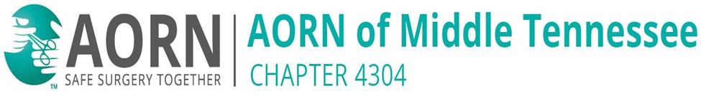

**JOIN AORN MIDDLE TENNESSEE CHAPTER 4304**

Empowering Perioperative Nurses.

Enhancing Patient Care.

**Now is the perfect time to become a member!**

AORN is offering an incredible membership deal for new members, just for YOU.

**Join for ONLY $1/month for the first 2 months!**

Then just $11.99/month after that – affordable, flexible, and packed with value!

**Why join AORN & Our Chapter?**

* Connect with fellow perioperative professionals in our community.
* Access exclusive education, leadership, and networking opportunities.
* Stay updated on best practices and policy changes.
* Make a difference in your OR and beyond.

**Middle Tennessee Chapter 4304**

We are a growing, enthusiastic group of nurses dedicated to supporting each other and advancing safe surgery through education, outreach, and collaboration.

Whether you are new to perioperative nursing or a seasoned pro – there is a place for you here!

**Don’t miss this opportunity to join a strong, supportive professional community.**

Let us grow together – one nurse, one voice, one chapter at a time.

**Sign up today at**

www.aorn.org/membership

**We can’t wait to welcome you!**

AORN Middle Tennessee Chapter 4304 – Where YOU Belong.

**Lead with the Heart!**