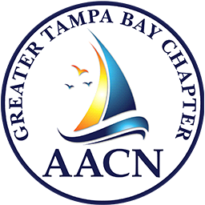
Greater Tampa Bay Chapter of the
American Association of Critical Care Nurses


Partners with Lincoln Elementary Magnet School – Plant City

Back to School Supply Drive

Most requested Needs from Teachers:
Also See Amazon Wish List!!
- Expo Markers – especially black ones (*ok if store brand)
- Tissues
- Band-aids
- Lysol / Sanitary Wipes
- Sticky Notes
- Glue Sticks
- Index Cards
- Card Stock Paper
**NOTE: Children also need basic supplies (pencils, pens, paper & notebooks, etc.) and teachers will save some for second half of year to hand out as needed.
Many students showed up to school last year without a 1-inch binder (due to expense) that is needed for many of the grades.

THANKS!!

