

**RMPANA Volunteer Opportunity – Feed the City Denver on**

**Saturday, August 23rd 2025**

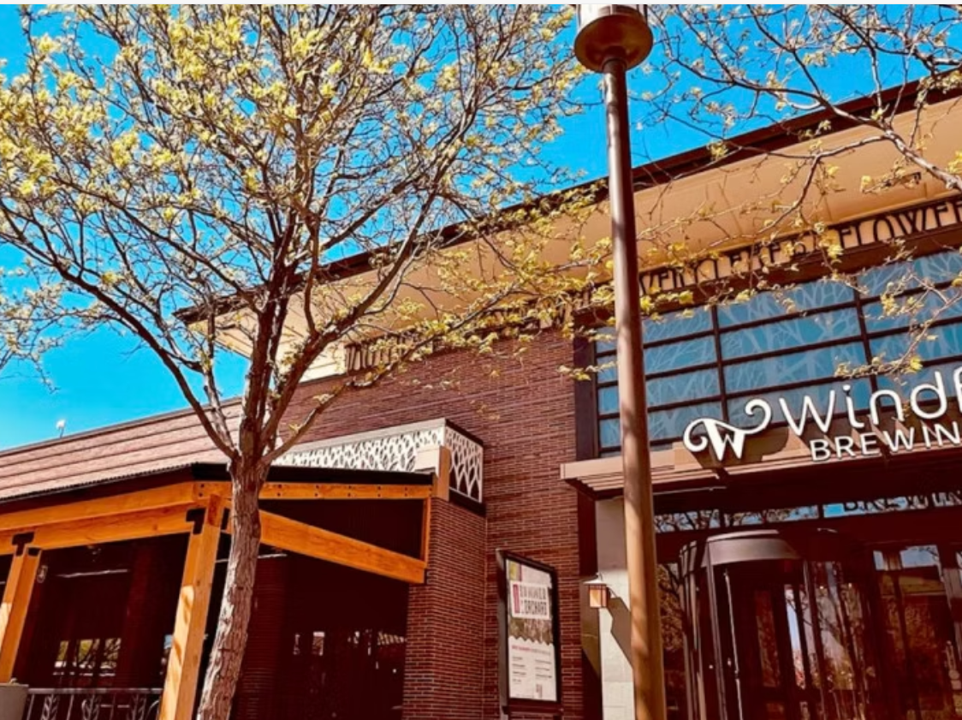

**RMPANA will donate food items for members to make bag lunches, but this volunteer activity is open to all! If interested in bringing additional family or friends reach out to** [**kristanicolehall@gmail.com**](mailto:kristanicolehall@gmail.com) **for more details. Sign up at RMPANA.com**

**HUNGER IN AMERICA.**

In America, over 46 million people live under the shadow of food insecurity. Hunger is a widespread issue all too often masked by pride, but its effects pervade all areas of life. Prolonged micronutrient deficiency leads to a weakened immune system, stunted growth, reduced cognitive ability, chronic disease, and even death.

*"Why should there be hunger and deprivation in any land, in any city, at any table, when man has the resources and the scientific know-how to provide all mankind with the basic necessities of life? There is no deficit in human resources. The deficit is in human will."*

**- Martin Luther King Jr.**

