IACNS Professional Development Award Overview
The Indiana Association of Clinical Nurse Specialist (IACNS) promotes and supports the contributions Clinical Nurse Specialists make through advancing our members’ professional development.
The IACNS Professional Development Award is funded and supported by IACNS. We encourage Clinical Nurse Specialists to propose opportunities that support the mission and vision of IACNS.
Available Funding
One or more proposal may be selected for the award annually, with funding up to $2,500.00.
Key Dates
- Application Window: July 20th – August 31st (by 11:59 PM EST)
- Award Notification: By November 1
- Announcement: At the annual IACNS conference
Specific Requirements for the Award:
- Applicant must -
  - hold a master’s or doctoral degree as a Clinical Nurse Specialist OR
  - be enrolled in an accredited program that prepares Clinical Nurse Specialists

- Applicant must be a member of IACNS with demonstrated engagement within the affiliate (e.g., business dinner attendance, webinar/conference attendance).
- Proposal must align with at minimum one of the following IACNS purpose statements:
  - Optimize the influence of CNSs in Indiana.
  - Advocate to advance nursing practice through national organizations and legislative representation.
  - Disseminate the outcomes CNSs have on healthcare’s quadruple aim.
  - Expand the CNS workforce through networking, mentorship, and leadership development.
Areas of Interest
- Disseminating CNS outcomes to other healthcare professionals and leaders
- Participating in professional development opportunity (e.g., conference attendance, certification, specialty education)
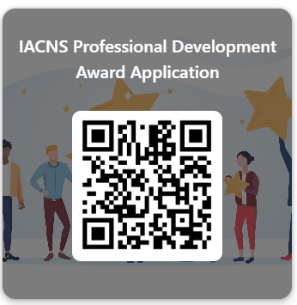
- Research study or implementation project quantifying CNS outcomes
To Apply
Submit your completed application via this link or QR Code https://forms.office.com/r/exvEwivArR.

