Piedmont District, region of NCAPAN, Presents

***The Dangers of Button Battery Ingestion: A Guide for Perianesthesia Nurses***

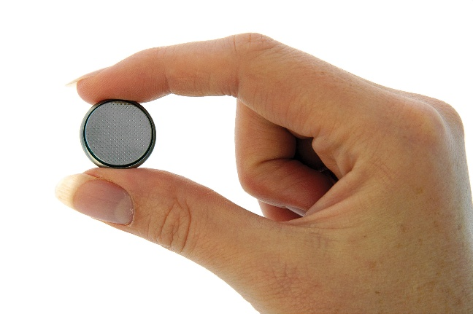

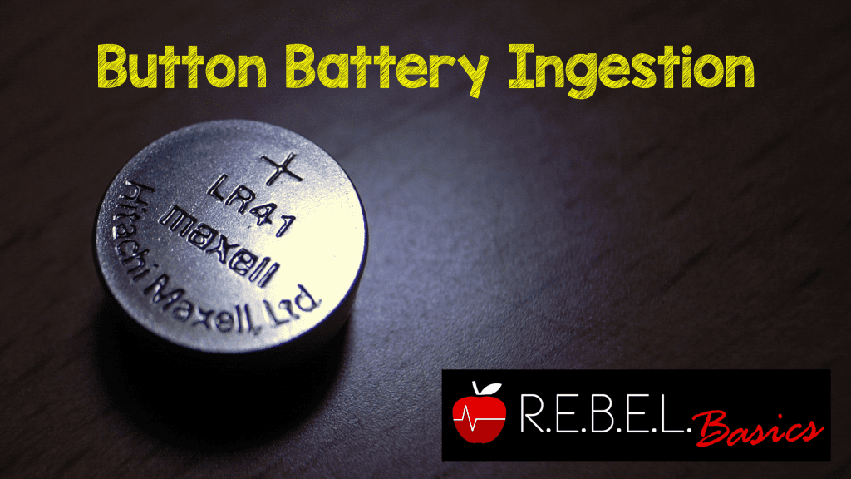

Join us on Tuesday August 26, 2025, at 7:00 pm via zoom!

<https://us02web.zoom.us/j/89988257129?pwd=KBjaFrXrc2ZAG73q5sIkSAyM2VDfRC.1>

Meeting ID: 899 8825 7129

Passcode: 730088

• +1 312 626 6799 US OR • +1 646 876 9923 US

*Pending approved for one contact hour by NCAPAN All are welcome to attend*