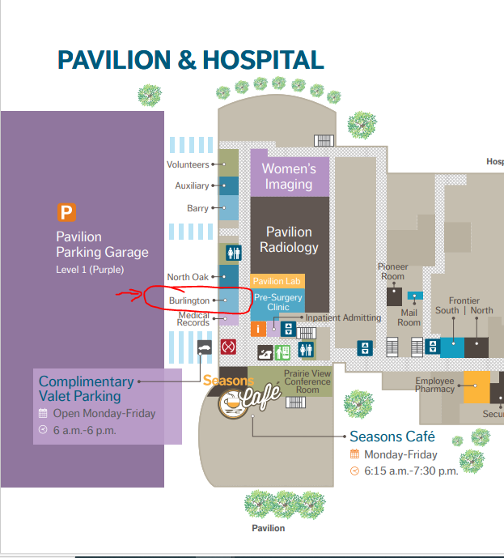

Burlington Room at NKC Health Pavilion
2790 Clay Edwards Drive
North Kansas City, MO 64116

