

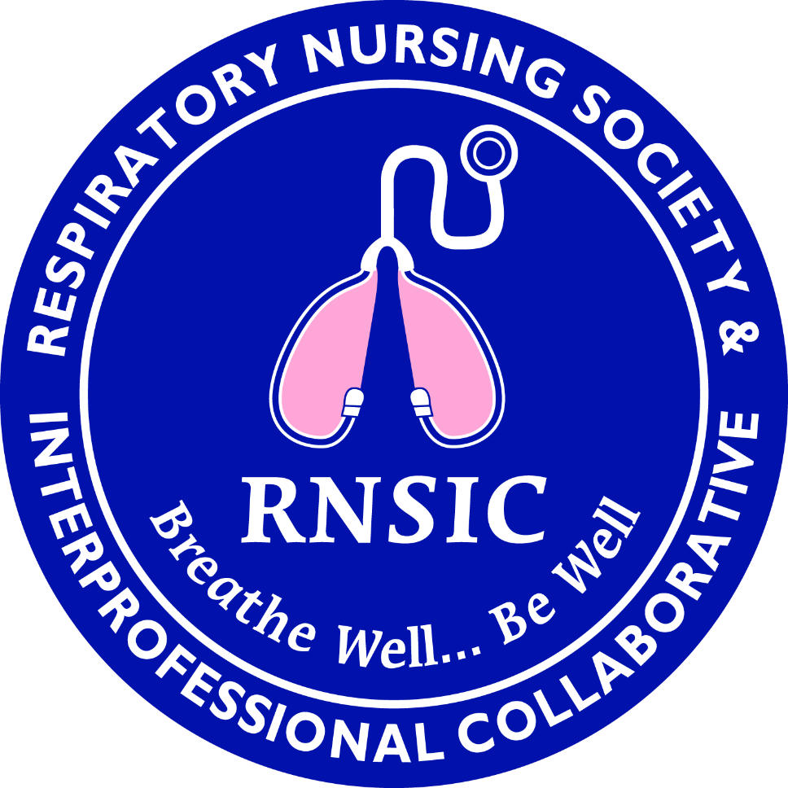

33rd Annual Educational Conference:

*Interdisciplinary Care Review of Pulmonary Patients*

August 15th & 16th, 2025

*The organization for healthcare providers who care for patients with respiratory problems.*

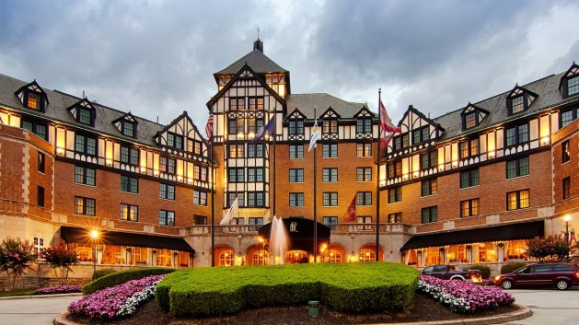

**In-Person Conference Attendance**

*The Hotel Roanoke & Conference Center*

Located in Roanoke, VA

“The Hotel Roanoke & Conference Center, Curio Collection by Hilton, and The Regency Room restaurant at the historic property, have been awarded the esteemed AAA Four Diamond Designation Rating for lodging and restaurants. The hotel is part of the exclu-

sive [Curio Collection by Hilton,](http://curiocollection3.hilton.com/en/index.html) a global portfolio of upper upscale, one-of-a-kind hotels and resorts all celebrated for their individuality.”

https://[www.hotelroanoke.com/southwest_va_hotel/](http://www.hotelroanoke.com/southwest_va_hotel/)

**To Submit an Abstract:**

Please go to our website:

[Respiratory Nursing Society and Interprofessional Collaborative | Nursing Network](https://rnsic.nursingnetwork.com/)

To contact an RNSIC member:

respiratorynursingsociety@gmail.com



Fee

33rd Annual Educational Conference August 15th & 16th, 2025

**RNSIC members:**

* Early Bird (before July 16th): $ **150**
* Standard (July 17th—August 1st): $ **165**
* Friday (August 15th): $ **115**
* Saturday (August 16th): $ **65**
* Late (After August 1st): $ **200 Non-RNSIC members**
* Early Bird (before July 16th): $ **225**
* Standard (July 17th—August 1st): $ **240**
* Friday (August 15th): $ **165**
* Saturday (August 16th): $ **85**
* Late (After August 1st): $ **275**

Does not include hotel accommodations or travel cost.

Registration

* On-line:

[Respiratory Nursing Society and Interprofessional Collaborative | Nursing Network](https://rnsic.nursingnetwork.com/)

**OR**

* Mail In Option Name:

Address:

City/State/Zip:

E-mail:

Make Checks payable to: Respiratory Nursing Society Mail to:

Regina Rackow

5133 Remmington Road

Roanoke, VA 24018

# Continuing Education Agenda

This year’s conference will be held in-person. Lectures must be viewed in entirety to be

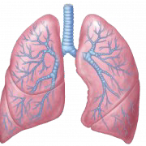

About Us

Our organization was created over 25 years ago by nurses who had a particular love for the care of patients with respiratory issues. This organization continues with the mission of better care for respiratory patients as well as professional growth for those caring for

them. We recognize that while this started as a nursing organization, it takes a team to care for this patient.

The Respiratory Nursing Society &

Interprofessional Collaborative (RNSIC) is a professional association for healthcare

providers interested in respiratory health and quality care for those with respiratory

disorders. RNSIC provides an opportunity for

those in a variety of practice settings to develop a strong respiratory knowledge base and skills important for quality respiratory

healthcare.

awarded educational contact hours.

This educational conference has been submitted to the Virginia Nurses Association for approval to

award contact hours for nurses.

This educational conference has been submitted to the American Association for Respiratory Care for approval to award contact hours for respiratory

therapists.

# Objectives

To offer healthcare providers current information relevant to the care and support of patients who suffer from respiratory disease.

# Agenda

**August 14th, 2025**

* Meeting held in The Pine Room
* 6 pm: RNSIC Board Meeting
* 630-7pm: Welcome Reception
* Light appetizers will be provided.

## August 15th, 2025

**7:15-7:45**: Check In

**7:45-7:55**: Welcome/Announcements

## 8:00-9:00: Dr. Sunny Arikat

Topic: Pulmonary Care of the Neonatal

## 9:00-10:00: Dr. David Killeen

Topic: Ventilator settings and why

## 10:00-10:30: Break/Poster Review

**10:30-11:30: Dr. Robert Keeley**

Topic: Pleural Effusions

## 11:30-12:30: Meenal Basu, RN, RPSGT, CCSH

Topic: Pleural Effusions: Out-Patient Care

**12:30-2:30: Lunch**

## 2:30-3:30: Kara Zacholski, Pharm D, BCCCP

Topic: Acute Chest Syndrome with Sickle Cell Crisis

**3:30-4:00: Break/Poster Review**

**4:00-5:00: Mattie Wertz, RRT**

Topic: Overview of Pulmonary Rehab

**5:00-5:15: Wrap Up/Evaluations & Certificates**

## August 16th, 2025

**7:15-7:45**: Check In

**7:45-7:55**: Welcome/Announcements

## 8:00-9:00: Dr. Fredrick Rawlins

Topic: MAC (Mycobacterium Avium Complex) lung disease: Causes, Symptoms, and Treatment

## 9:00-10:00: Dr. Brijesh Patel

Topic: Pulmonary Hypertension

**10:00-10:30: Break/Poster Review**

**10:30-11:30: “A Nurse’s Journey”**

Topic: Nursing Panel Discussion

**11:30-12:00: Wrap-Up/Evaluations & Certificates**

(Topics and speakers may change prior to conference)