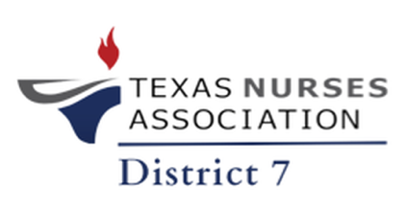
Texas Nurses Association: District 7
UMHB NEC 114
Belton, Texas
Virtual - Microsoft Teams
Monday, June 7, 2024, at 6 PM CST
- Call to Order
- Welcome/opening remarks: “Networking in Nursing!”
- Roll Call (Establish Quorum)
- Approval of the Minutes: 5/5/2025
- Correspondence
- State & District Reports
  - District Report
    - Membership Report
    - Treasurer Report
  - State Report/TNA Update
    - Policy Council
    - Government Affairs Committee (GAC)
    - Board of Directors (BOD): Annual Conference, Roadshow
- Committee Reports
  - Awards Committee: Need chairperson
  - Audit/Finance Committee: Need chairperson
  - Bylaw Committee: Monday, June 9, 2025, at 6 PM CST on Teams
  - Communications Committee: Need chairperson
  - Early Career Nurse Committee: Need chairperson
  - Government Affairs Committee: Need chairperson
  - LVN Committee: Need chairperson
  - Nominating/Elections Committee: Need chairperson
  - Nursing Practice Committee: Need chairperson
  - Program/Events Committee: Need chairperson
  - Scholarship Committee: Need chairperson
  - Strategic Planning Committee
    - Strategic Planning Session 1: Sunday, June 8, 2025, Teams
    - Strategic Planning Session 2: Sunday, June 22, 2025, TBD
- Business
- Open Floor
  - LVN Committee/LVN Membership
  - District 7 Expansion
- Announcements
  - Next Meeting: “Nursing Innovation” on Monday, July 7, 2025, at 6 PM CST, AccentCare (Temple Branch) and Microsoft Teams
- Adjournment

