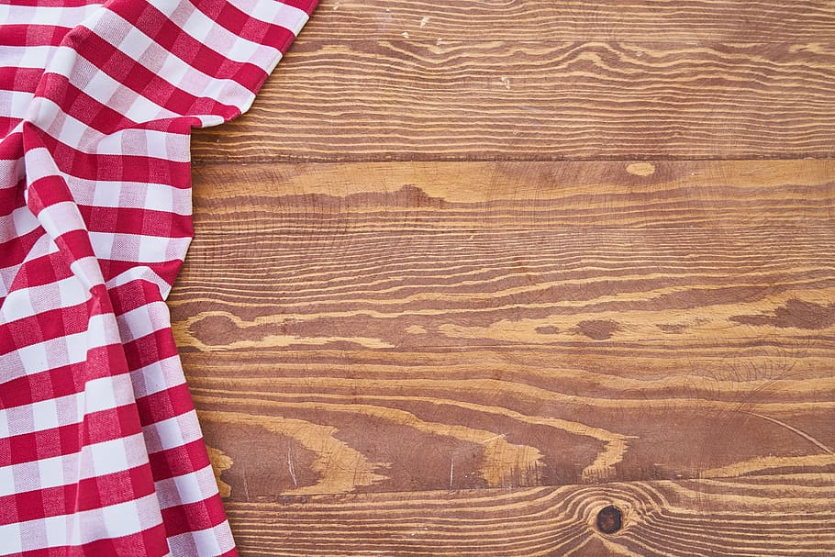


Don’t miss our annual picnic in the park.

Where: Kirkwood Park
When: Sunday June 1st
11:30-4:00
What to bring- a lawn chair
a side dish to share and be sure to bring your own drink.
We will be at the Campbell Pavilion
A water cooler will be available. We will provide chicken salad as well as a vegetarian option.

Come and enjoy this great time of sharing.

We look forward to seeing you!

