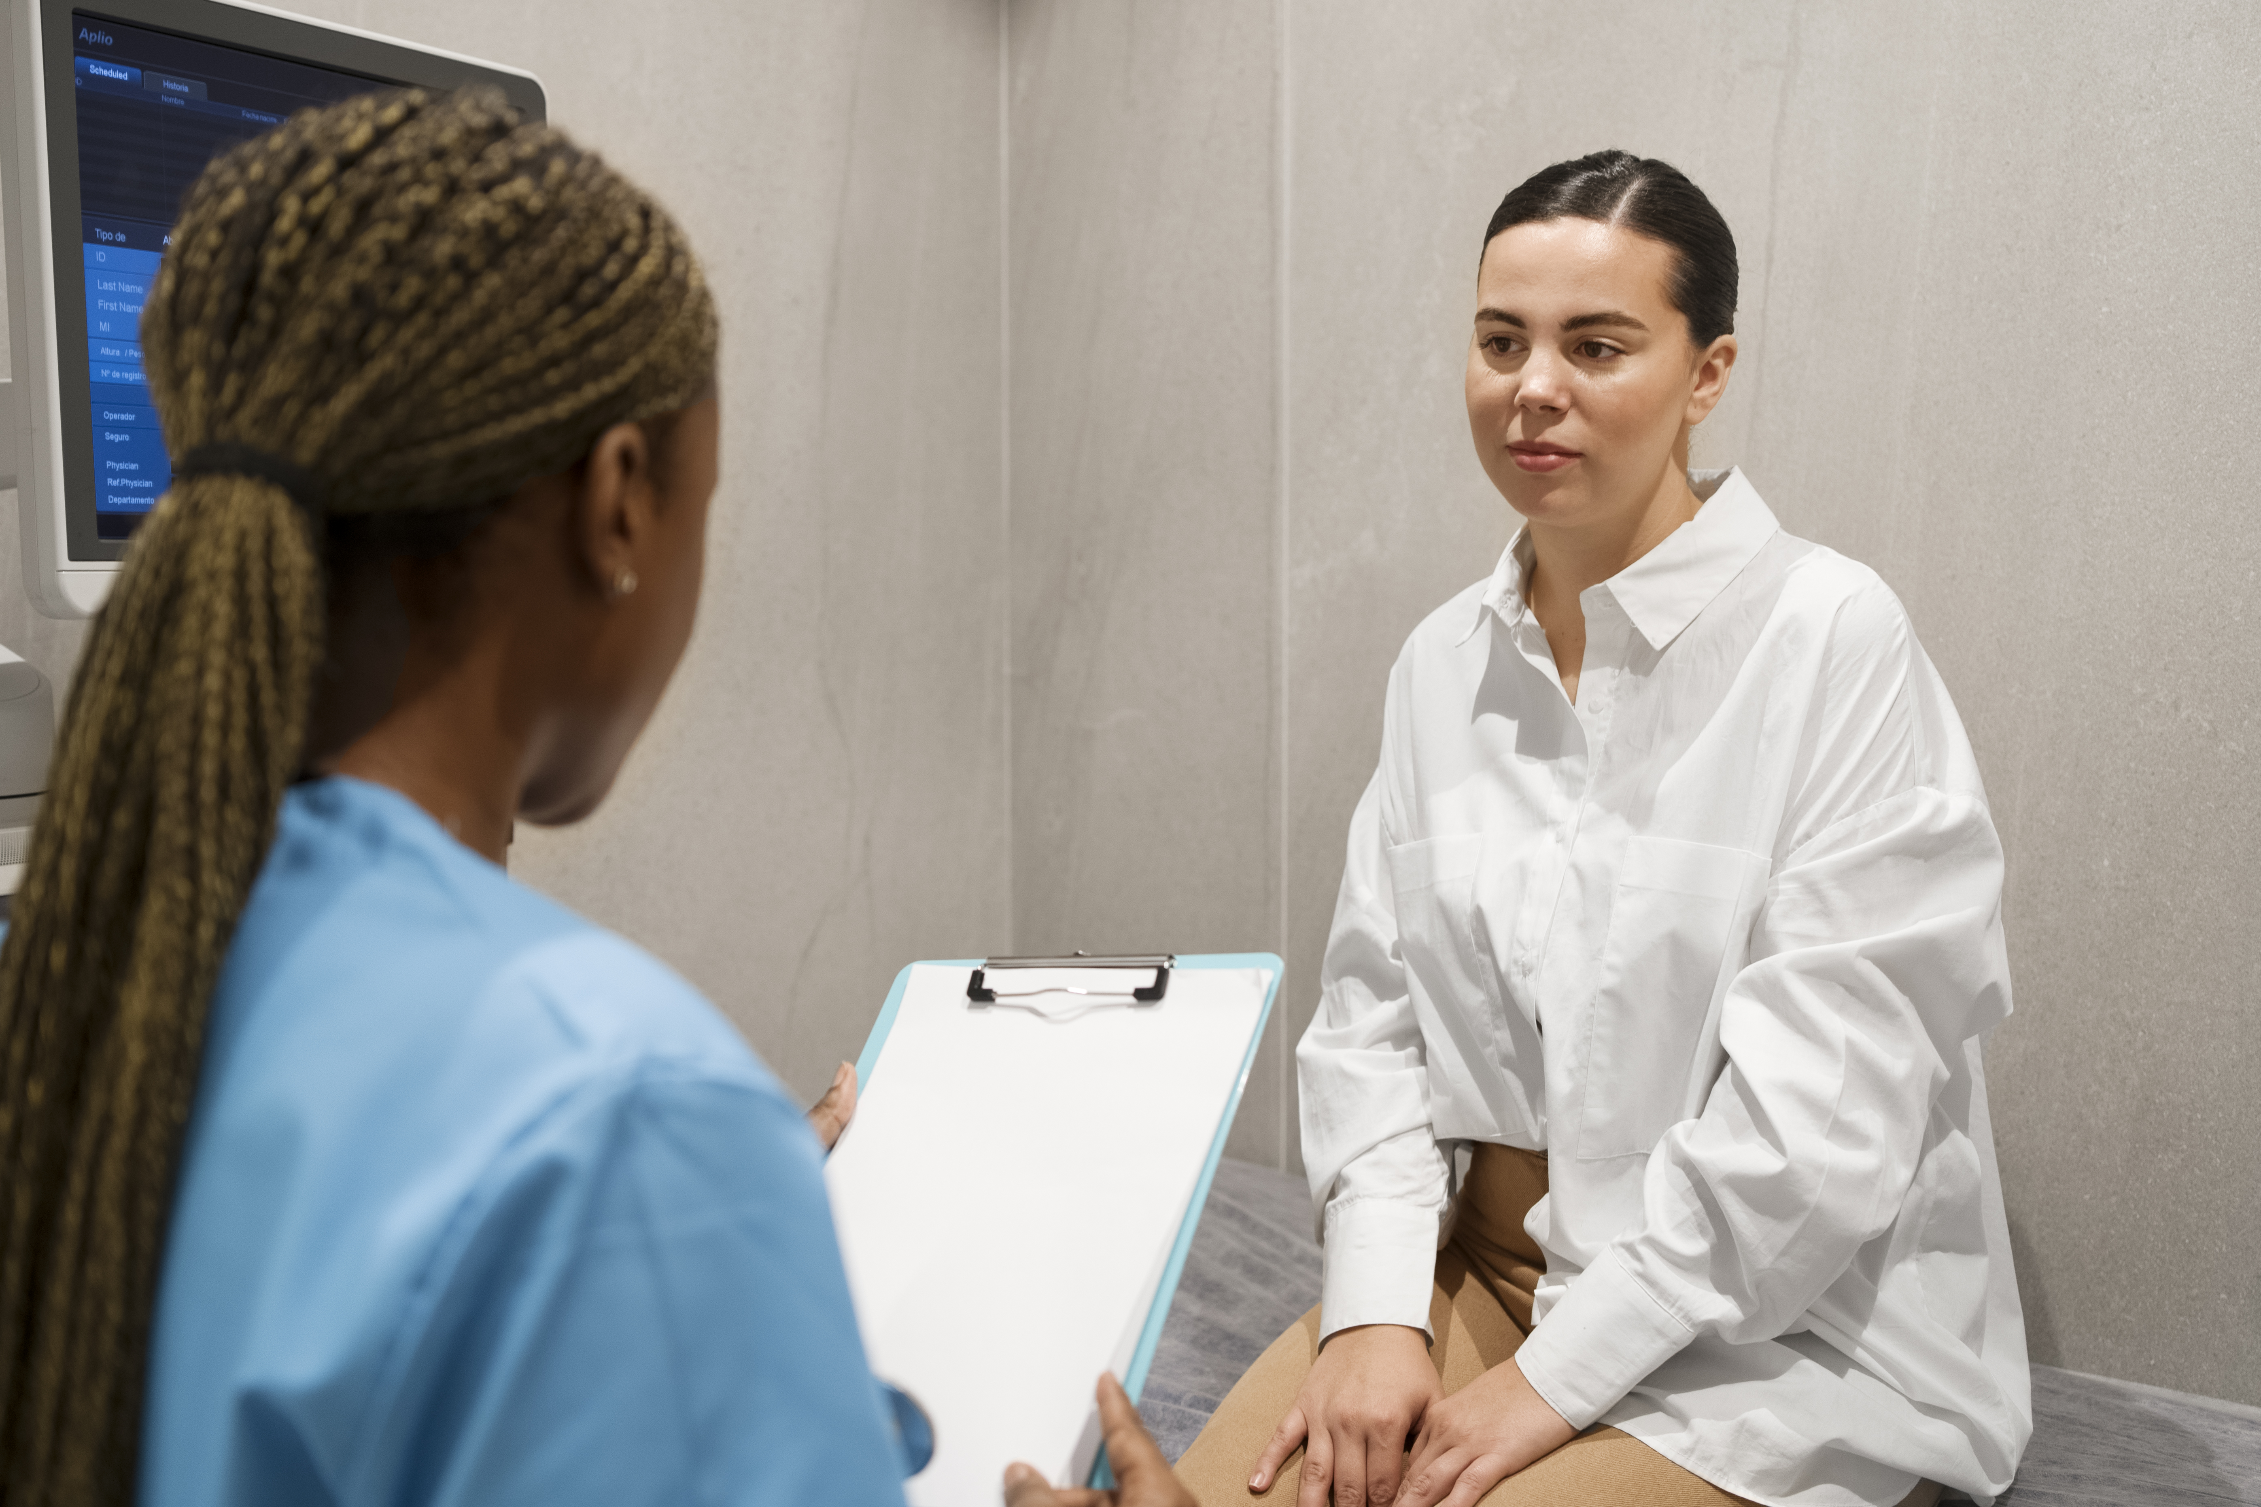  Monday, 6.16.2025  - LIve Webinar  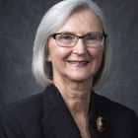  SBIRT Screening &  Diagnosis of SUD  NACDN is proud to offer this one-hour nurse continuing education offering via Zoom to members (free) and guests ($10). Marian Currens, CRNP, RN, a past NACDN President and recognized nationally for her dedication to the field of SUD, will be presenting SBIRT Screening & Diagnosis of SUD (SBIRT = Screening, Brief Intervention, & Referral to Treatment). This presentation will be informative to nurses in multiple disciplines. Register today @ www.nacdn.org – select the event tab.  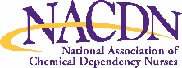 | 6.16.2025 @ 5:30PM ET  1.0 Nurse Contact Hour  Free for NACDN Members!  Guests $10  Members & Guests must register at www.nacdn.org  National Association of Chemical Dependency Nurses  4132 E. Joppa Road Suite 110-1110  Baltimore, MD 21236  (410) 849-0525  www.nacdn.org

