

**home page when using the link below.**

**You will have to click on RNSA, or if you have not previously established our group, add it to your groups.**

<https://www.nursingnetwork.com/user>

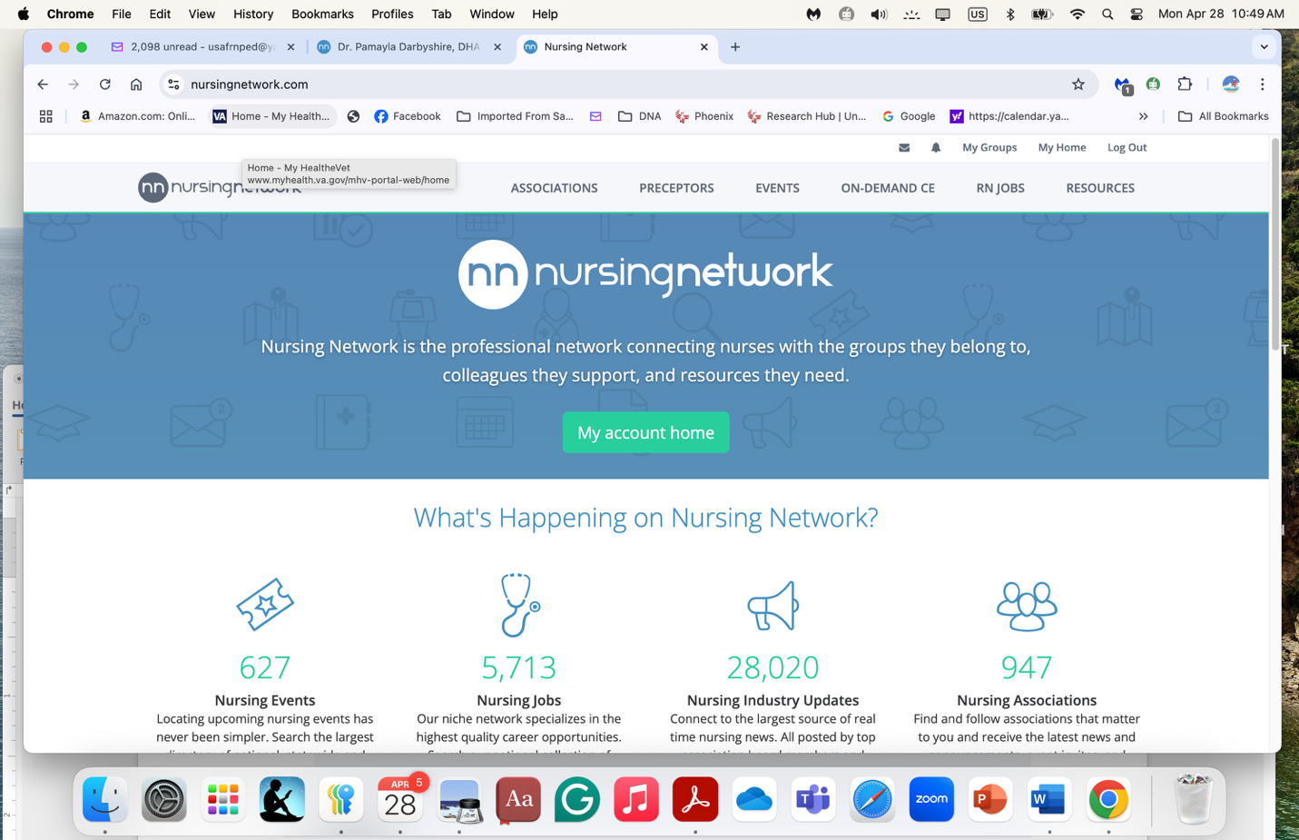

Click on ‘my account home’

Will take you to this page

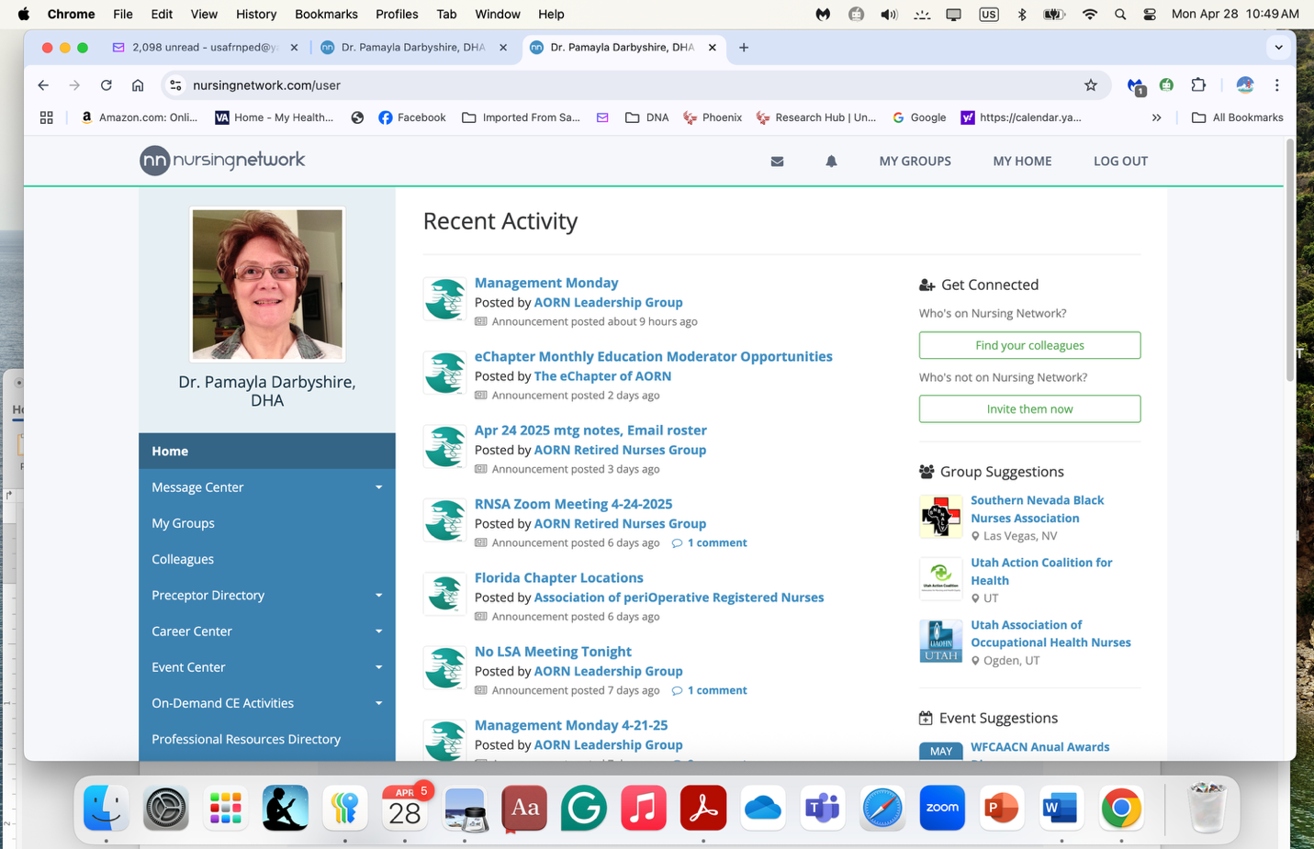

On the toolbar, click on ‘my groups’

That page will show all your groups. You can also click on the blue dropdown menu on the left where my groups are located.

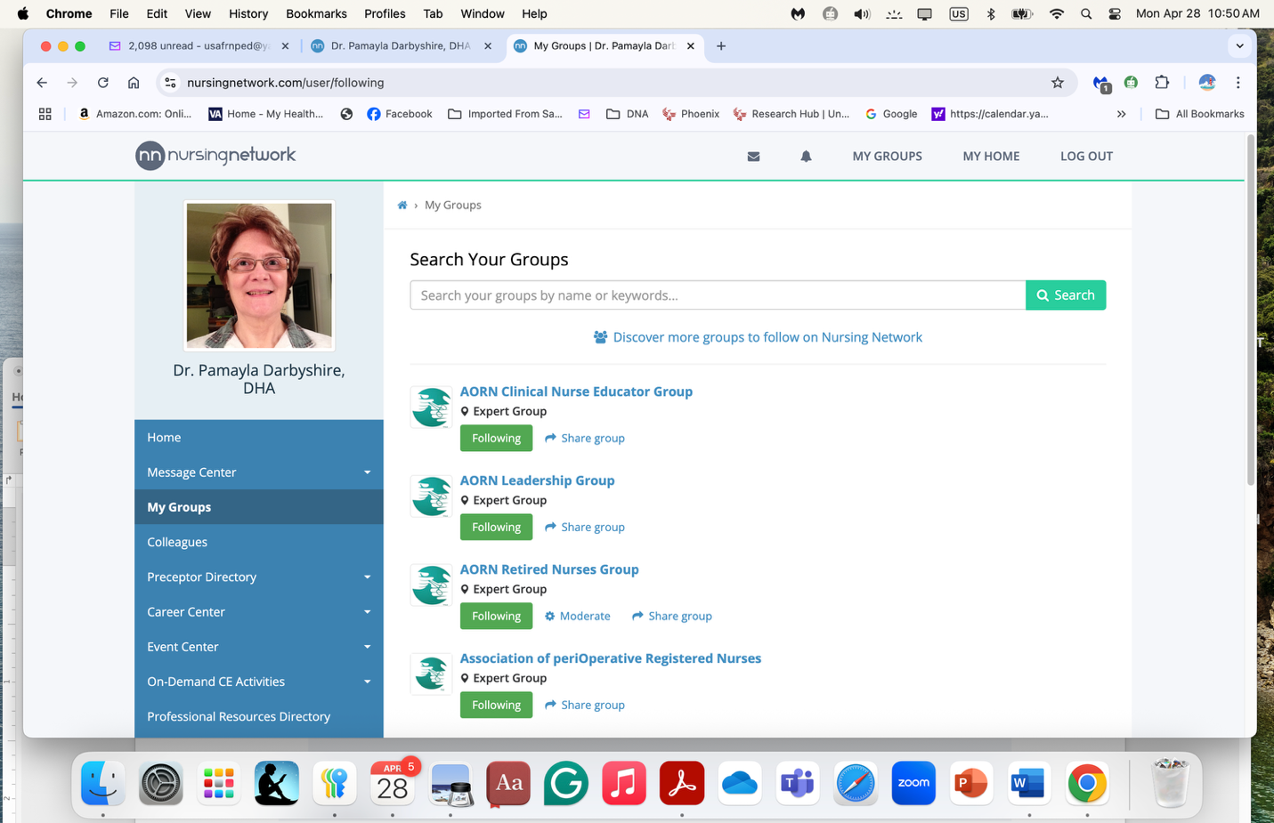

A quick look for some RNSA names indicates you are members of our group.

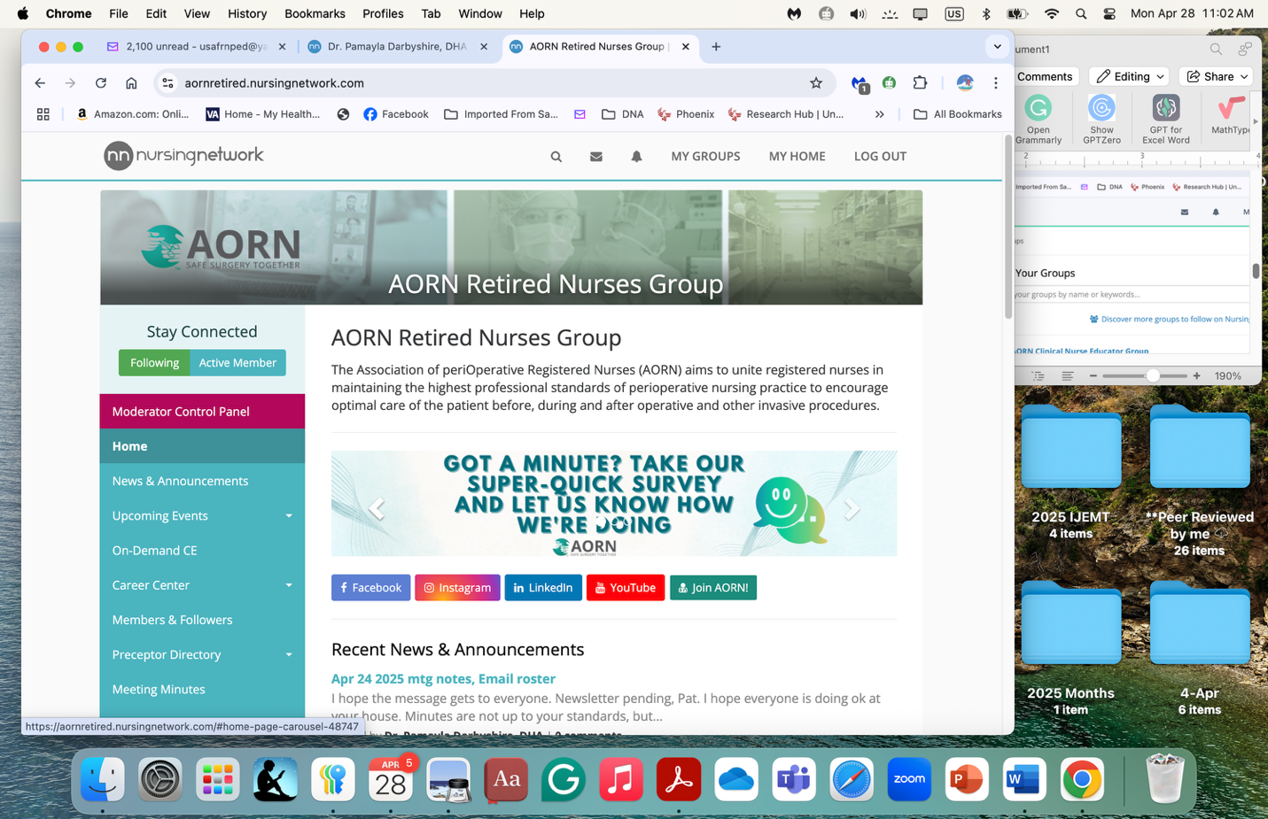

Make sure you are following our group and are an active member of our group.