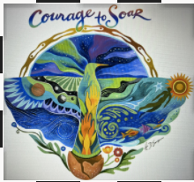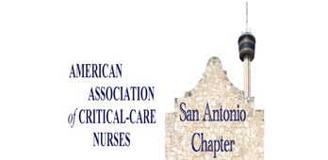  Hypoxemic Respiratory Failure  May 27, 2025 6:00-8:30 pm  Presented by:  Dr. Arturo Lopez  RSVP Required:  https://sachapteraacn.nursingnetwork.com/  http://www.facebook.com/SAchapterAACN/  or scan the QR code below  SAN ANTONIO CHAPTER AACN  Live Dinner Meeting and Education Event  Location: J Prime Steakhouse  1401 N. Loop 1604 W.  San Antonio, TX 78232  Dinner Provided  (Non-member donation- $25.00 – to support conference scholarships; and can be used to join the local chapter for one year, if a member of national AACN) Please note that no shows will be tracked, if your registration is not cancelled twice in 6 months due to being unable to attend, you will be placed on a waitlist for future available seats. Refund for non member fee if notified 7 days prior to event with fee utilized for local membership.)  This activity has been submitted to the American Association of Critical-Care Nurses for approval to award contact hours. The American Association of Critical-Care Nurses is accredited as an approver of nursing continuing professional development by the American Nurses Credentialing Center’s Commission on Accreditation | Schedule  6p-6:15p registration  6:15-6:30  Dinner Served  6:30-7:30p  Education Activity  7:30-8:00p  Chapter Meeting  8:00-8:30p  Vendor Presentation  Adjorn  Register:  sachapteraacn.  Nursingnetwork.com  Dinner Sponsor:  Frescenius  Medical Care

